Right click on the Unity Desk Top Icon and select Properties
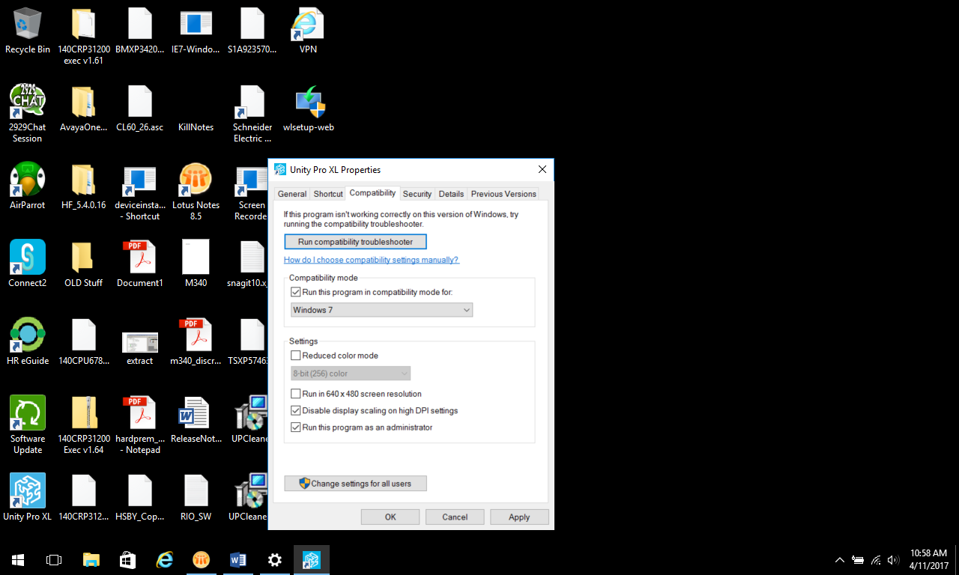

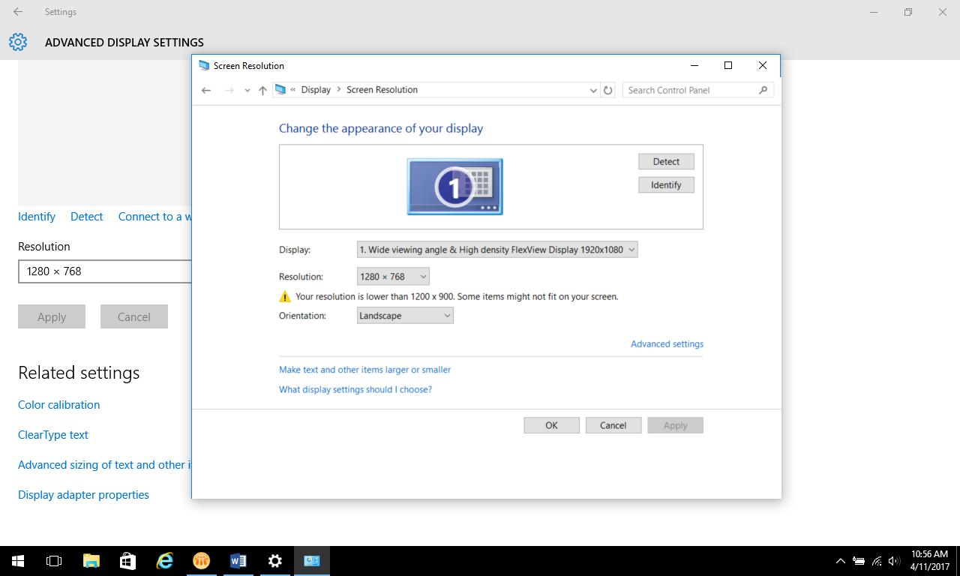
Select the following resolution

