While offline select Project Settings

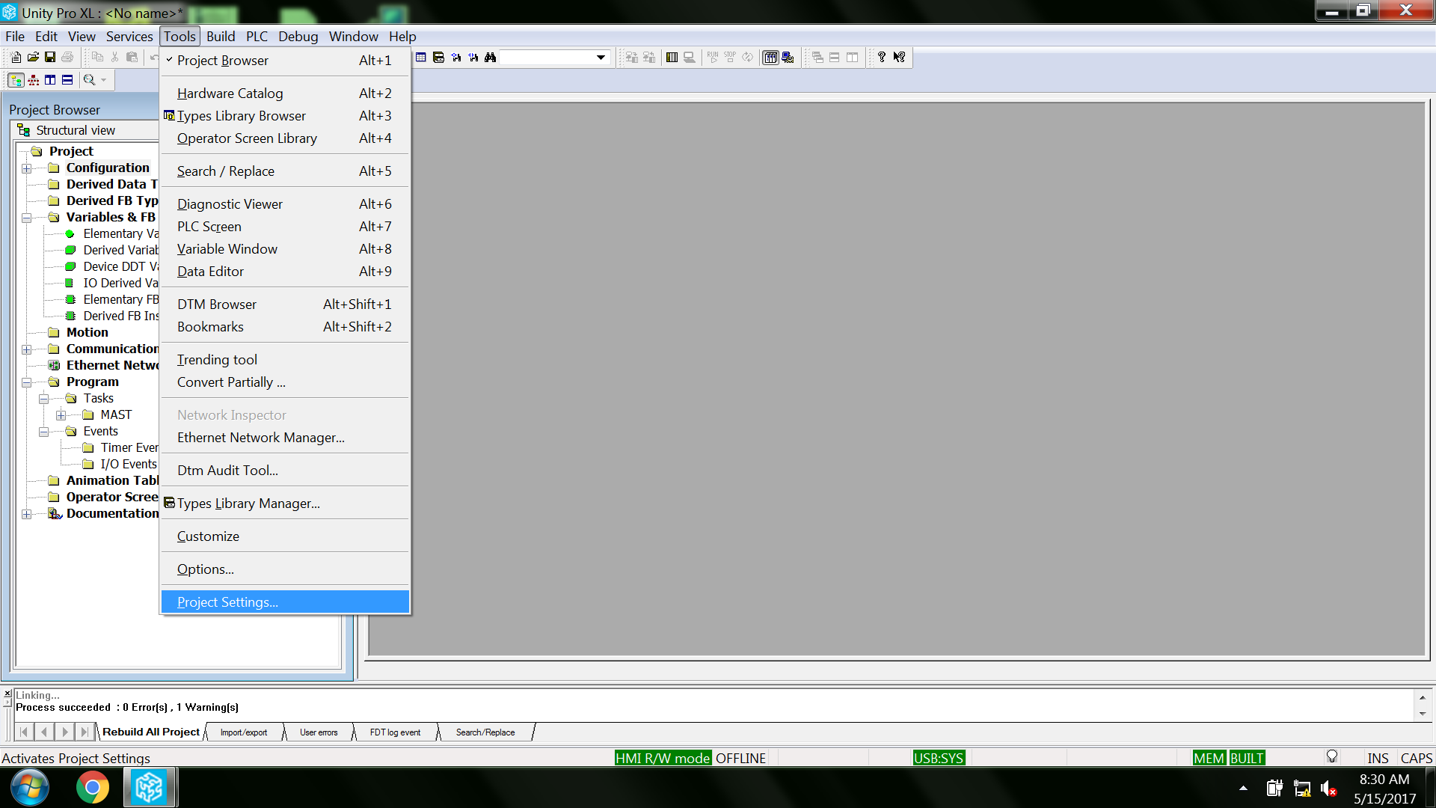

Select: Time.
Select: Coordinated Universal Time
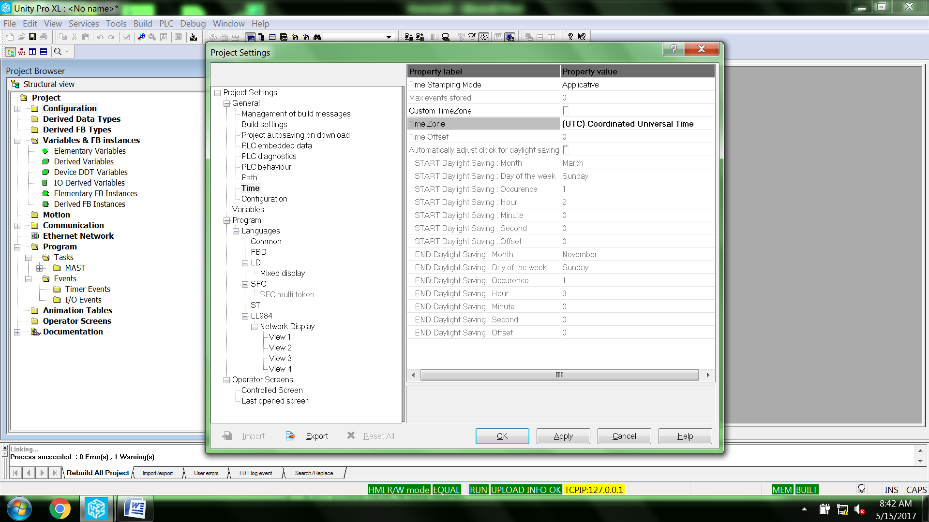

While online select Tools\PLC Screen
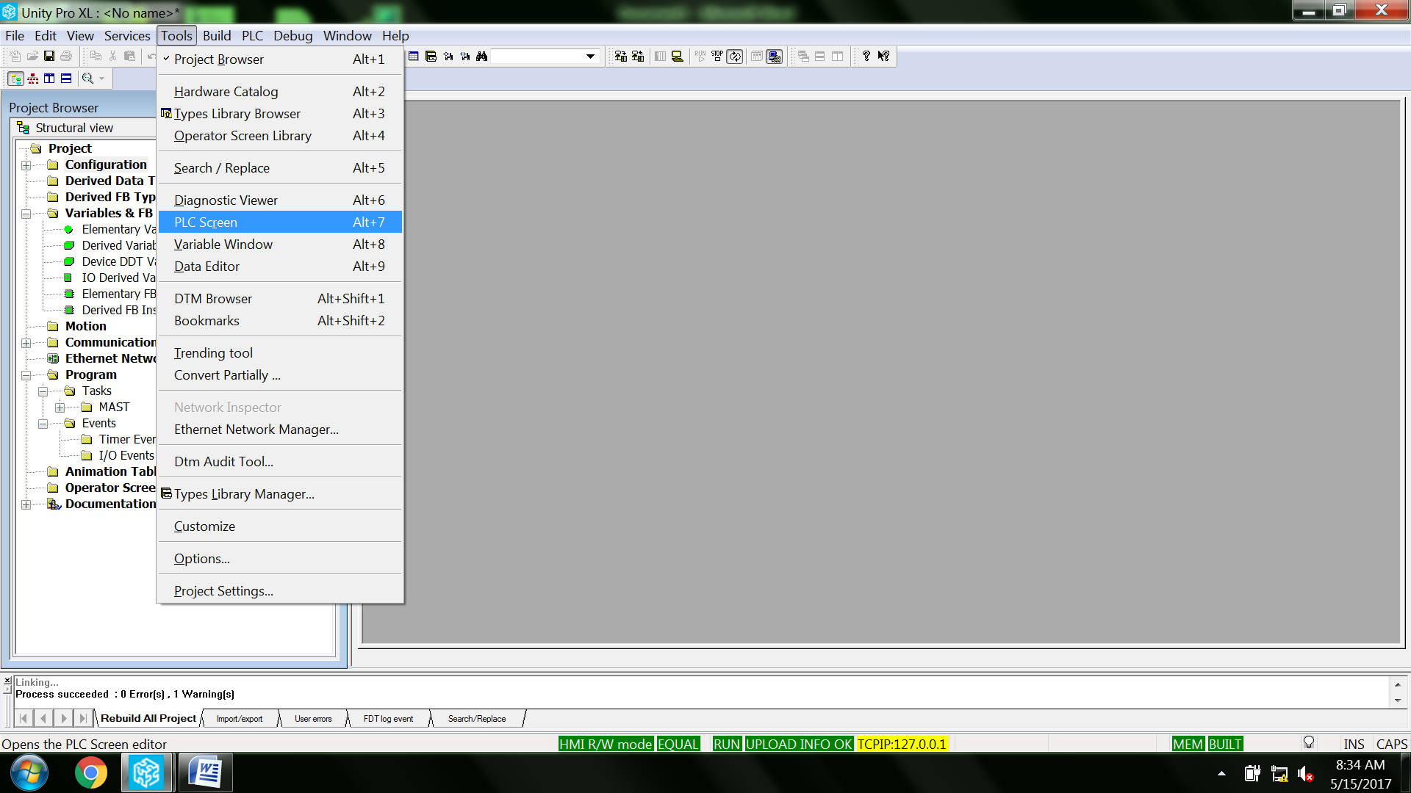

You can now initialize the PLC clock with your PC time (left tab) Otherwise you can enter a preset time of your choosing (right tab) Access to the RTC values are available in %SW49 – 53
