How to connect a pressure transducer to Altivar Process for PID control?
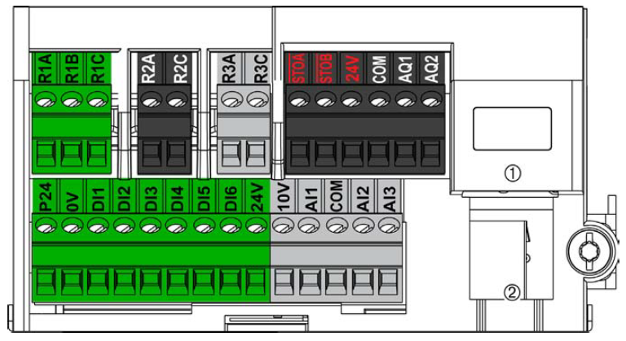

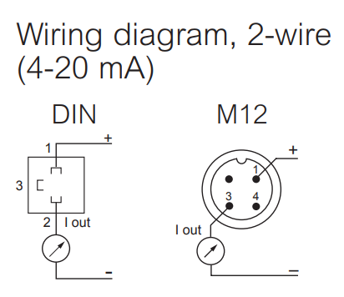
24VDC, 4-20mA output

Terminal 1 of transducer to be connected 24V
Terminal 3 to be connected to AI1 or AI2 or AI3 for feedback

(please make sure to change the Analogue input type to current)

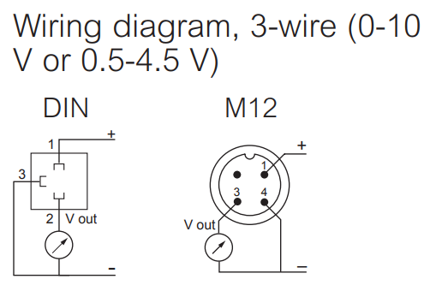
24VDC, 0-10VDC output

Terminal 1 of transducer to be connected 24V
Terminal 3 to be connected to COM
Terminal 4 to be connected to AI1 or AI2 or AI3 for feedback

(please make sure to change the Analogue input type to voltage)

