Framework Migration ION7x50 – ION9000

Guidelines for Custom Framework Migration

V 1.2

Prepared By: Fabricio Ribeiro

August 2018

Description and Objective

This document summarizes the framework differences between the ION7650 product family and ION9000 product family, highlighting the incompatibilities between the two offers providing a general guideline to migrate custom solutions built on the legacy platform to the new ION9000 product.

It is expected that customers currently using custom programming on the ION7x50 platform will need to migrate such customizations to the new ION9000 products. This document should act as a general source of information to understand the main differences between the platforms and assist customers to migrate such frameworks.

Framework Capacity Differences

On the new ION9000 meters several ION programming modules have been modified to support new capabilities and functionalities of the new platform.

The ION modules that have their quantities modified, either increasing the number of modules available for custom programming or were removed are summarized on the table below.

 | Quantity of Modules Available
ION Module Name | ION7650 V401 | ION9000
AndOr | 50 | 100
AnalogInput | 4 | 16
AnalogOutput | 4 | 8
Arithmetic | 70 | 100
Comtrade | 2 | 3
Counter | 50 | 100
Convert | 80 | 100
DigitalInput | 16 | 32
DigitalOutput | 9 | 16
Display | 90 | 40
DataRecorder | 50 | 100
DNP_Slave_Export | 25 | 100
ExternalBoolean | 75 | 100
ExternalNumeric | 40 | 100
FFT | 9 | 13
GgioExpansionMap | 1 | 4
HarmonicsAnalyser | 9 | 0
Harmonics_Evaluation | 16 | 24
Harmonics_Measurement | 12 | 24
Modbus_Master_Input | 64 | 0
PeriodicTimer | 20 | 30
PulseMerge | 50 | 128
Pulser | 9 | 10
Scroll | 10 | 0
Security | 16 | 50
SnmpMapping | 3 | 5
Store | 50 | 60
SymmetricalComponents | 2 | 3
TrendingForecasting | 10 | 20
Web_Page | 50 | 0
WaveformRecorder | 18 | 21

Please note that the Harmonics Analyser, Modbus Master Input, Scroll and Webpage modules have been completely deprecated on the new platform.

The Display Modules have been structurally modified in such way that the modules used on the ION7650 framework are not compatible to the new platform, the customer will need to recreate all custom displays using the new module structure.

The number of Arithmetic modules in the new platform have been increased in addition to the number of input registers of each module. The new modules have 16 input register instead of 8.

Impacts on Default Framework

The default framework shipped with the ION9000 meters have all the features of the default framework of the ION7650 meters with added features to support updated standard requirements.

Note that other modules have been modified internally to expand their application and support updated standard requirements. There is no need to use default framework from the ION7x50 platform on the new meters to accomplish the basic functionalities.

Due to the structural changes on some modules and modifications on the new platform, the use of some modules on the default framework of the ION9000 meter may differ from the default framework on the ION7x50 meters. It is recommended to review the inputs of all custom framework to make sure the correct data is being used.

Framework compatibility

Considering the architectural differences of the ION modules used on the ION7x50 and the ION9000 meters, importing a complete framework from the ION7x50 meter into the ION9000 is not possible. The programming application, either ION Setup and PME designer, will not allow a complete framework paste between the 2 products.

The usage of modules from the ION7X50 meters on the ION9000 meters may compromise compliance to specific standards, as the mode of operation, inputs and outputs may differ between the 2 platforms. It is not recommended to overwrite or replace any of the modules existing on the default framework for the ION9000 meters.

Custom Solutions

The ION9000 meter will be able to accept any custom programming built for the ION7x50 meters, as long as it does not replace any of the default modules and it does not contain any of the deprecated modules. It is not recommended to perform any lock paste using PME designer of custom framework solutions as it may overwrite modules used on the default framework of the ION9000 meter. Additional details are provided on the next section.

Custom programming will need to be partially pasted over the ION9000 default framework. Advanced users should be able to accomplish such task using PME designer and the framework export from the ION7x50 meters containing only the modules used on the custom application.

It may become necessary to manually relink all the custom modules to the default framework. This link should be based on the quantity tag or the data relevant for the custom solution and not on the module and output register number.

Best Practices

The easiest procedure to migrate custom framework solutions is using PME Designer application, where the customized piece can be easily identified and copied over from an ION7x50 meter to the new ION9000 meters. This procedure requires familiarity with the tool, and the basic steps are described below.

The first step is to identify and copy the custom solution built on the ION7x50 meter framework. For this use the PME Designer application.



Open the diagram from the meter that contains the custom framework.

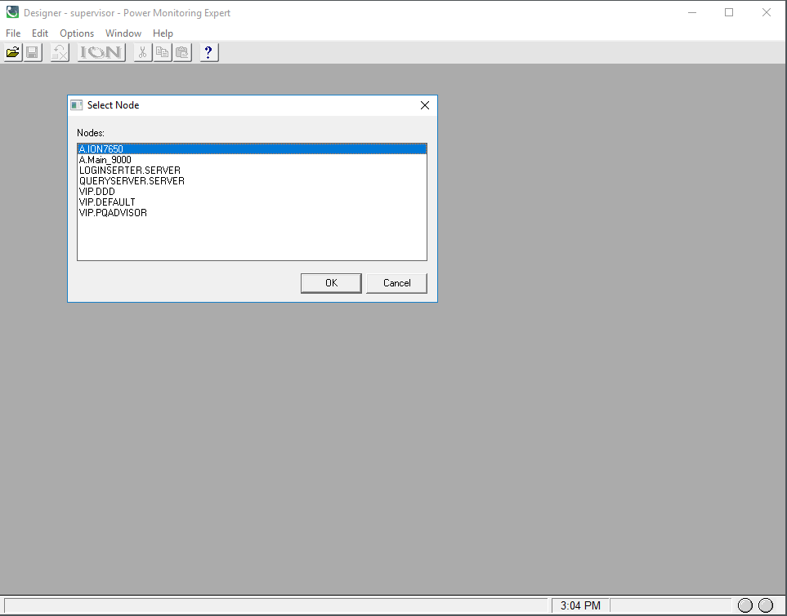

Once the meter diagram is open the, the customized piece should easily be identified. If it is the first time the meter diagram is open on the system, all the custom modules will be placed together on a single grouping module.

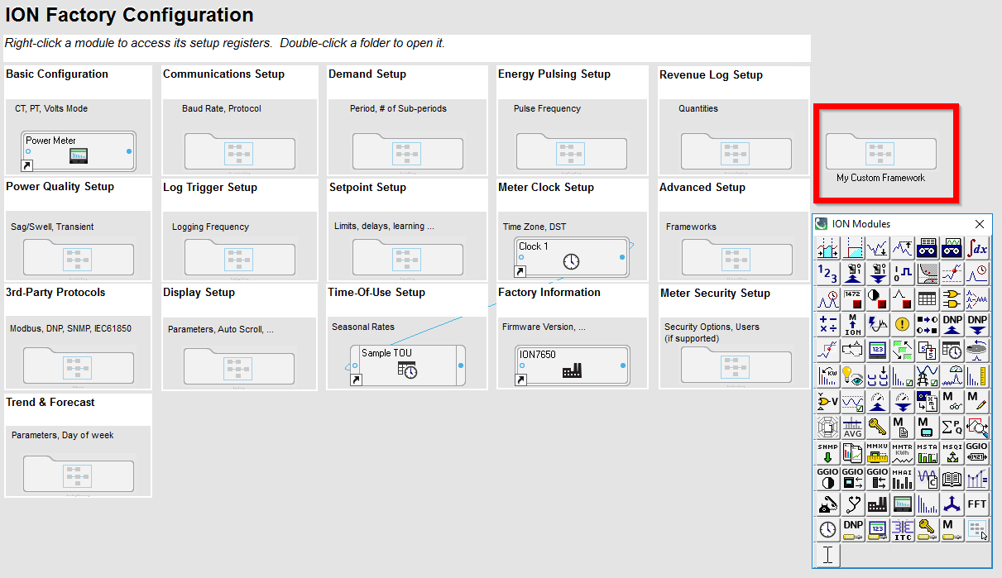

The next step is to copy the part of the diagram that should be migrated to the new meter. To perform this operation the modules, or the grouping module must be selected and the option to “copy to framework” must be used to generate a FWN file. This file will only contain the modules selected and not the entire meter framework.

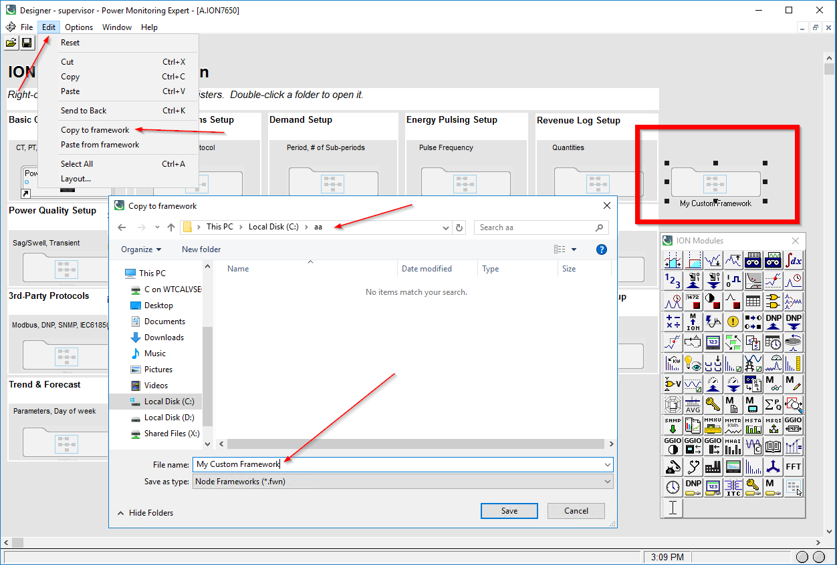

Once the file is saved on the computer, it is time to paste the modules into the new ION9000 meter. To perform this operation, it is necessary to open the ION9000 meter diagram on Designer.

(ATTENTION: DO NOT PASTE THIS PARTIAL FRAMEWORK USING OTHER TOOL AS IT CAN OVERWRITE THE DEFAULT MODULES ON THE ION9000 METER).

The ION9000 meter diagram on PME designer should look similar to the image below.

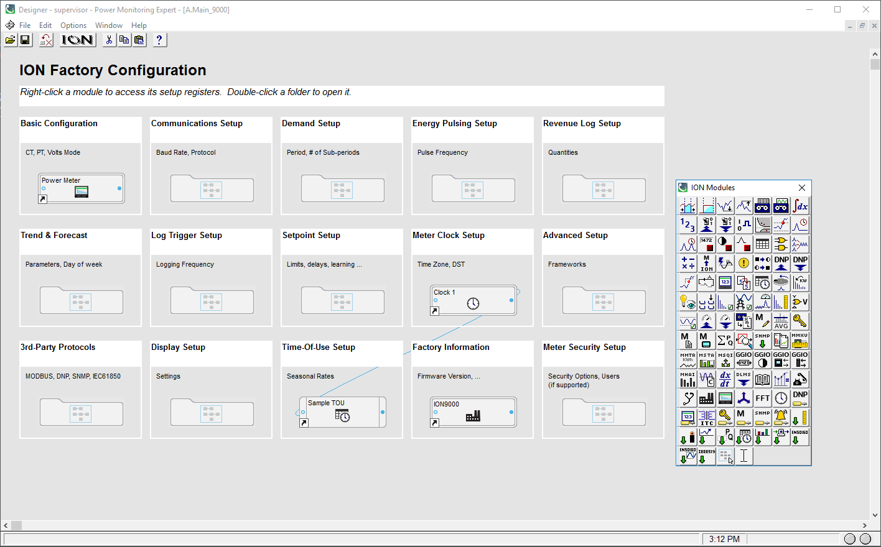

To paste the partial framework to the meter, it is necessary to use the option “paste from framework” as described on the image below. This operation will ADD the modules to the default framework on the ION9000 meter.

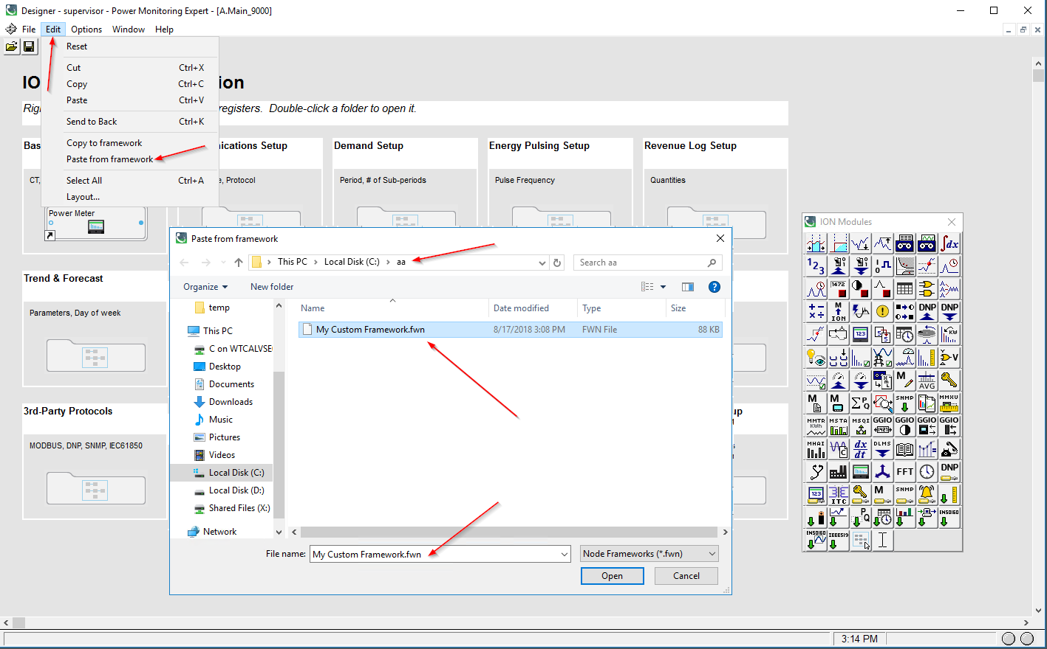

When performing this operation, the PME designer application will identify which modules will be created, with the new module numbers. Note that no module will be overwritten, avoiding any complicit with the default framework running on the ION9000 meter.

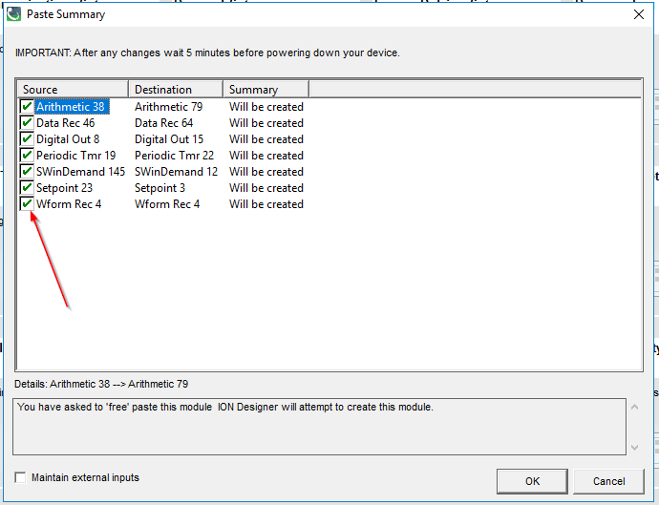

(ATTENTION: DO NOT USE LOCK PASTE AT THIS STEP AS IT CAN OVERWRITE MODULES OF THE METER DEFAULT FRMEWORK, AFFECTING THE OPERATION OF THE DEVICE, OR SOME OF THE METER BASIC FEATURES)

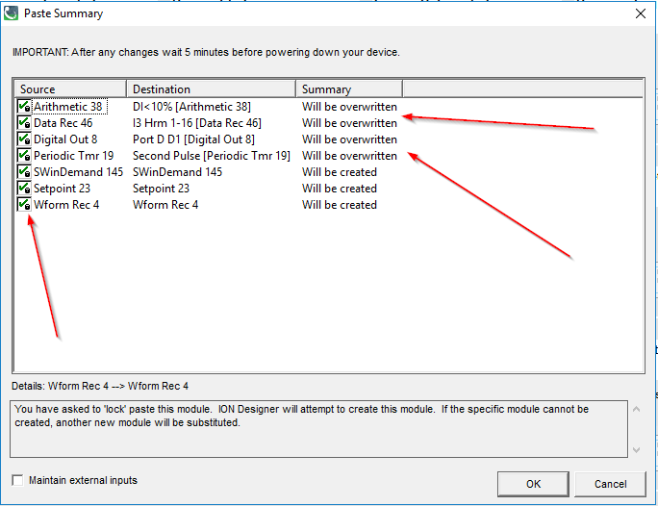

Once the custom modules are created it is necessary to re-link all the inputs to the meter default framework. This requires knowledge of the application and the type of information required, the framework on the IONx50 can be used as reference but note that the labels may have changed from the ION7x50 to the ION9000 meter, and it is important to check if the information used is correct.

One alternative to assist on the links between the custom added framework and the default framework is to use the option “maintain external inputs”.

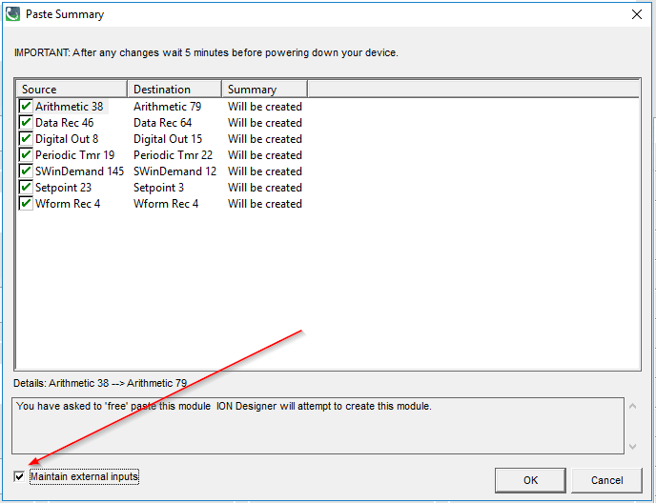

Keep in mind that these links are based on the output labels of the default framework, and they may have changed from the ION7x50 meter to the ION9000 meter. Even after using this feature, all inputs and outputs much be checked if they are linked properly and if they contain the correct information required by the custom framework.

Once the paste is completed the new modules will be activated after saving the framework changes. At this moment it is possible that some modules will display an error message, mainly due to new setup registers introduced on the modules. Please use the messages to identify the missing configuration and complete them as needed.

The updated ION Reference document should describe all setup registers for each module and can be used to assist the configuration of the modules on the new ION9000 meter.

For additional support and instructions, please reach out to the Schneider Electric Technical support team in your country. Visit the website below to identify the phone and E-mails contacts recommended for your country.

https://www.schneider-electric.com/en/work/support/country-selector/contact-us.jsp

