02-2019

Fixing TSX C USB 485 cable driver error 39, 28 or similar
Symptoms:
- Can happen after major Windows update.
- TSX C USB 485 cable driver (driver for cable TCSMCNAM3M002P) returns error 39, 28…
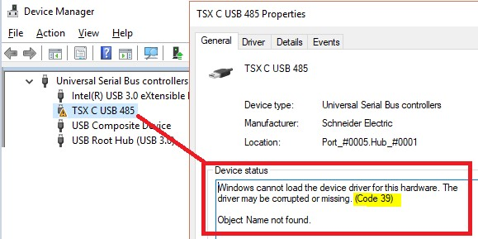
Prerequisites:
- REMARK for Windows 7 PC’s:
New MB driver signature is SHA2 - type.
Win7 must be updated – it’s mandatory to have the following patches installed:
Win7 64-Bit:
Windows6.1-KB3033929-x64.msu
Windows6.1-KB3035131-x64.msu
Win7 32-Bit:
Windows6.1-KB3033929-x86.msu
Windows6.1-KB3035131-x86.msu

- Make sure that TSX C USB 485 cable is not plugged in the PC.

Resolution:
- Uninstall all the SE-Communication Drivers (Modbus, PLC USB, XIP, FipIO, Unitelway…) using DriverManager or, from Control Panel -> Programs & Features.
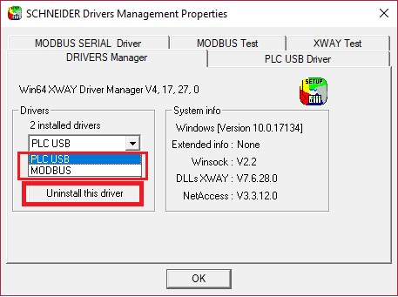
- Uninstall DriverManager (since V14.12.0.0, this can be done via Control Panel -> Programs & Features)
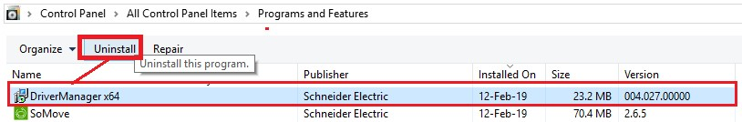
For older DriverManager versions, uninstallation requires searching by Regedit → follow the Appendix 1.

- Reboot PC
4) Download the newest SchneiderModbusDriverSuite (14.13.0.0):
https://schneider-electric.box.com/s/0i8dx90gez28gzb1dlii0eez2gt9pg1c
- Install SchneiderModbusDriverSuite (14.13.0.0)
- Reinstall DriverManager and all SE-Communication Drivers
Schneider Electric | Industry Business | Drives - VSD CCC Expert Centre (GHD - MKW)

Appendix 1
Uninstalling Driver Manager 14.11.. or older
Run Regedit.
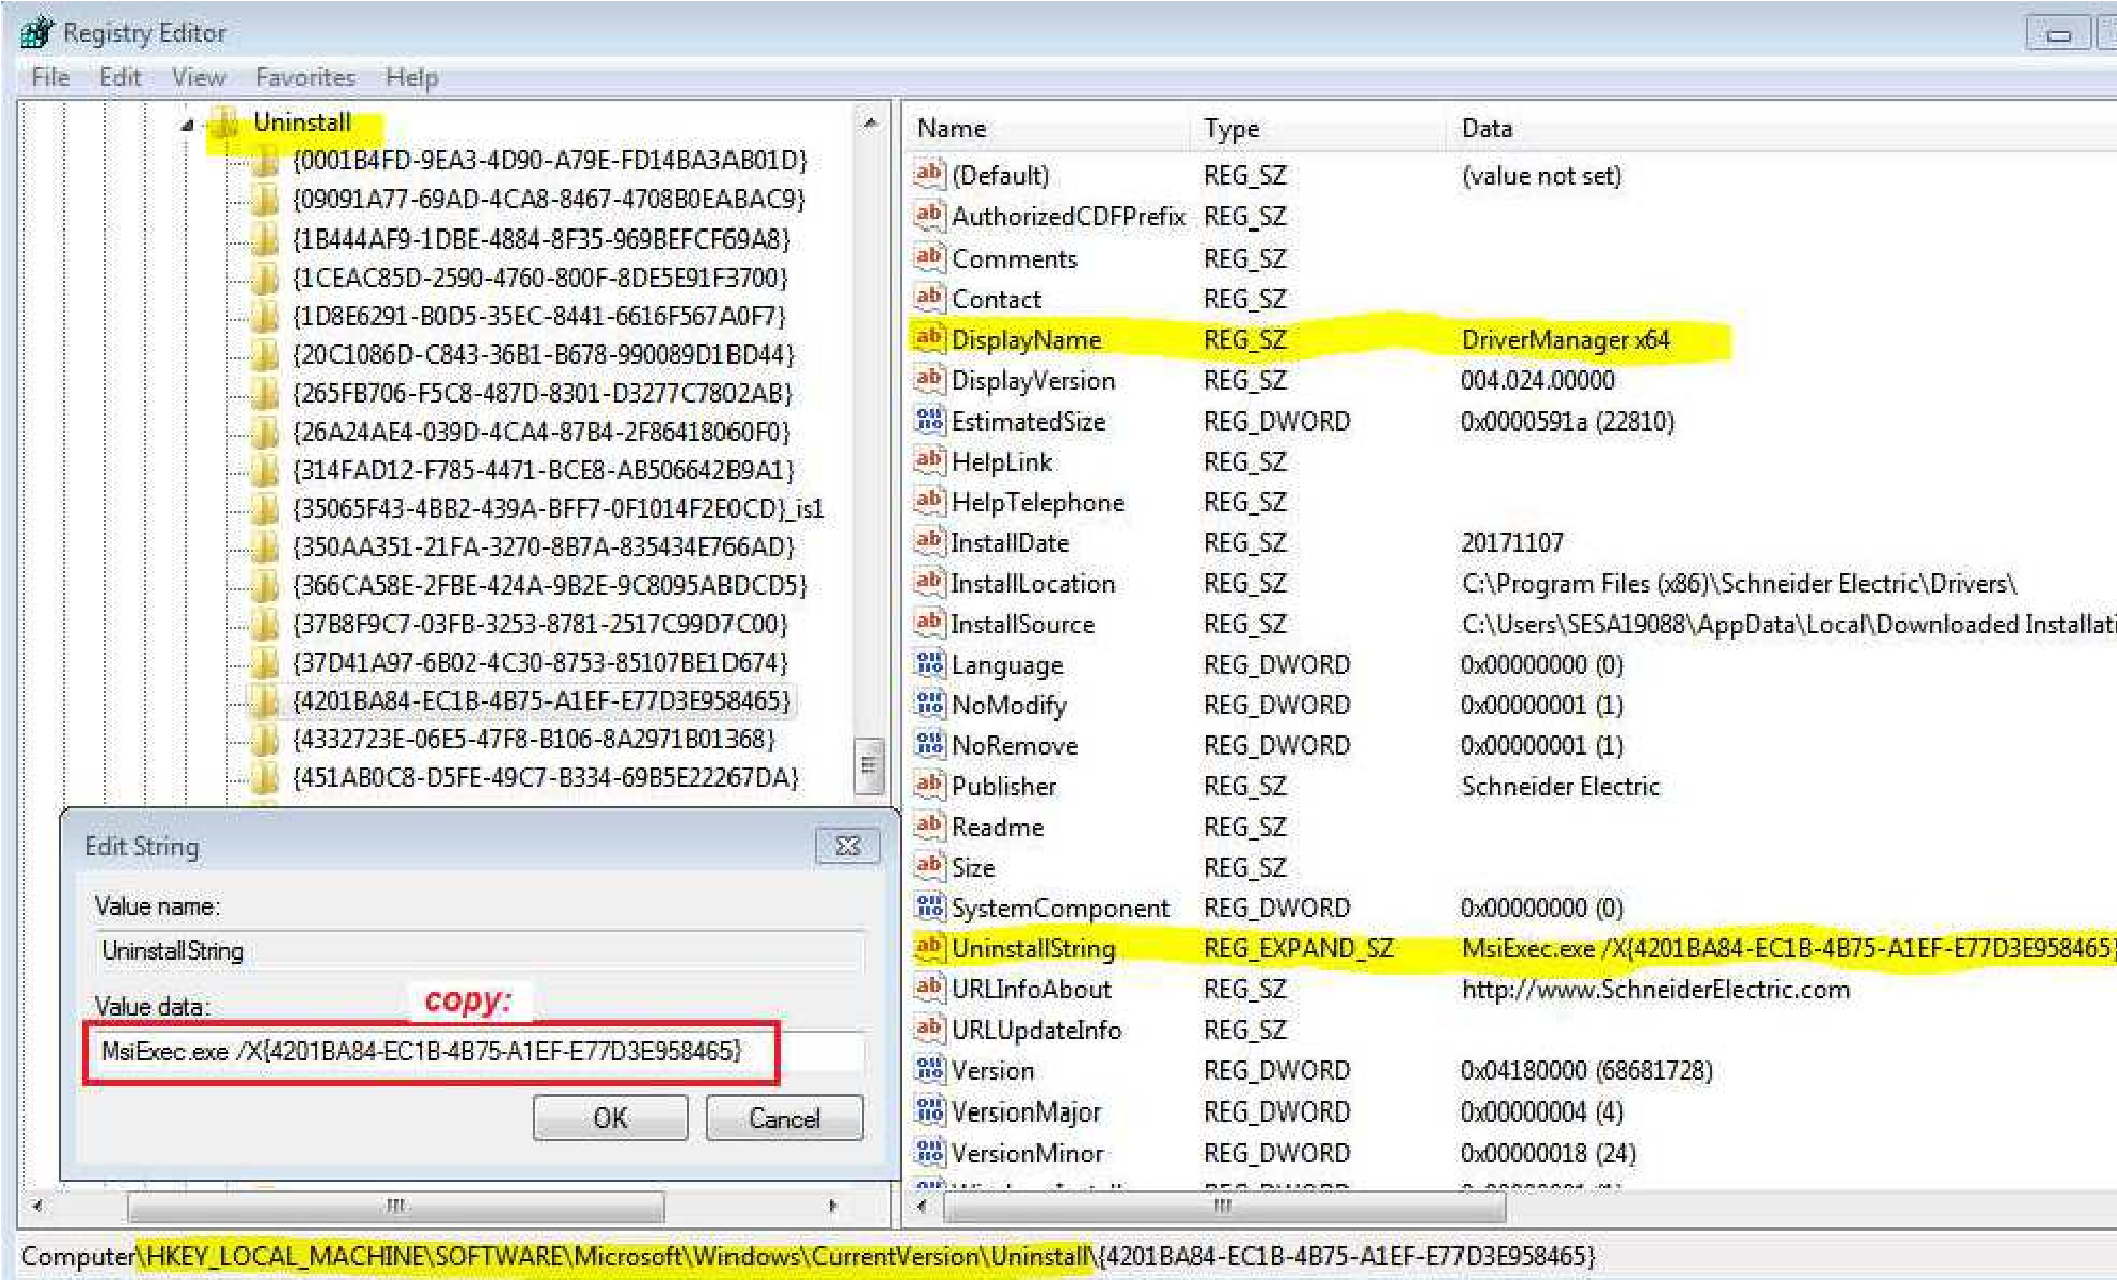
Navigate to: HKEY_LOCAL_MACHINE\Software\Microsoft\Windows\CurrentVersion\Uninstall Search for the folder that contains the key DisplayName DriverManager X64 and UninstallString. Open the UninstallString and copy this string
Click Windows Start button, paste and execute the UninstallString in order to uninstall the DriverManager X64:
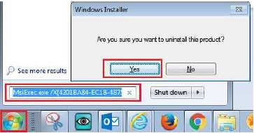
Schneider Electric | Industry Business | Drives - VSD CCC Expert Centre (GHD - MKW)

