Is there a way to use a physical switch to on/off ERMS, like in the case of Masterpact NT/NW?
Yes you can use ESM module:
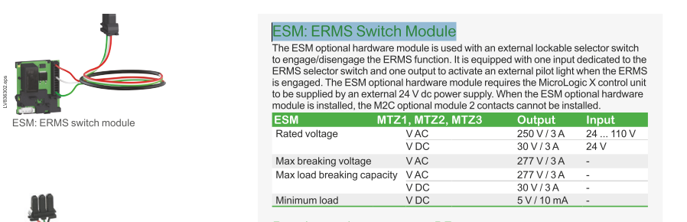
Please note that if you install ESM module you can not install M2C module;
The reference of this module is LV836300SP.
This module will allow you to use a push button to engage and disengage ERMS.
See schematic below:
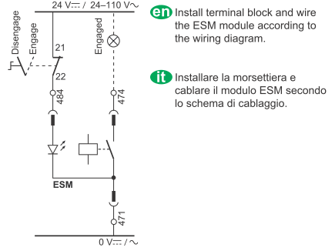
The installation is described in the doc attached.
LV836300SP IS.pdf
NOTE: to be operational, ESM-ERMS must be declared with Ecoreach.

