Frame size 11 and 12 are ATV61HC16 thru HC22N4
Frame size 13 and 14 are ATV61HC25N4 thru HC50N4
Frame size 11 and 12 are ATV71HC13 thru HC16N4
Frame size 13 and 14 are ATV71HC20N4 thru HC40N4
Frame size 15 is ATV61HC63N4
Frame size 15 is ATV71HC50N4

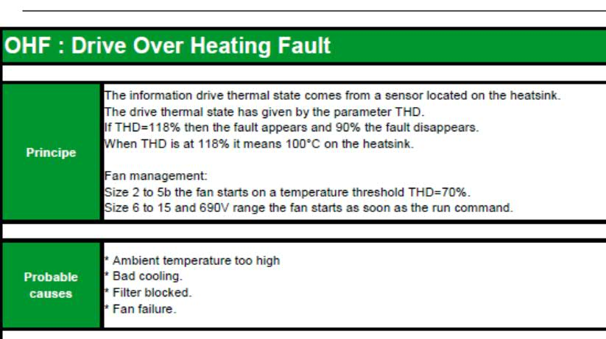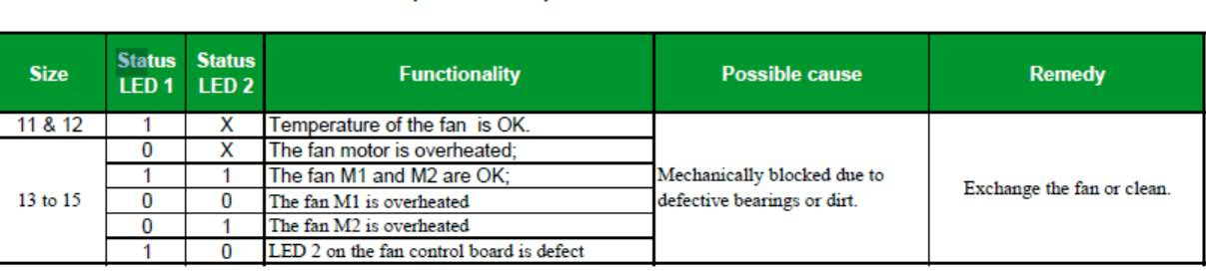
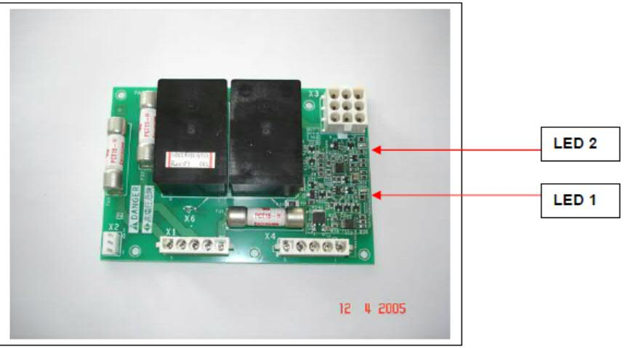

Heat sink fan is part number VZ3V1212

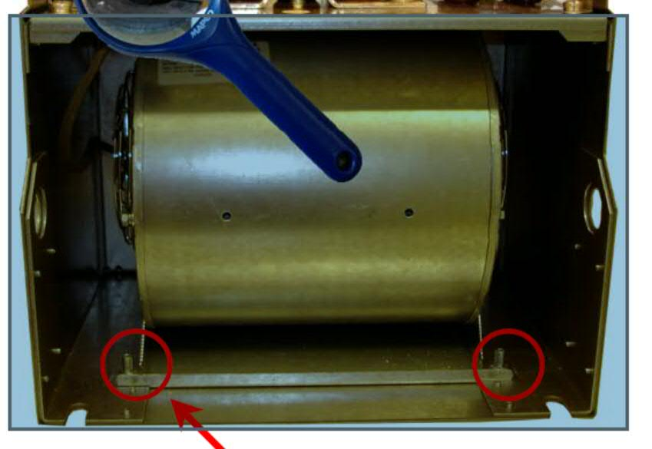

Frame size 11 and 12
1 Fan control board (VX5A1400)
1 Heat sink fan (VZ3V1212)

Fame size 13
1 Fan control board (VX5A1400)
2 Heat sink fans VZ3V1212

Frame size 14
2 Fan control boards (VX5A1400)
3 Heat sink fans (VZ3V1212)

Frame size 15
2 Fan control boards (VX5A1400)
4 Heat sink fans (VZ3V1212)

Frame size 11 and 12 are ATV61HC16 thru HC22N4
Frame size 13 and 14 are ATV61HC25N4 thru HC50N4
Frame size 11 and 12 are ATV71HC13 thru HC16N4
Frame size 13 and 14 are ATV71HC20N4 thru HC40N4
Frame size 15 is ATV61HC63N4
Frame size 15 is ATV71HC50N4

