Here’s what happens if the ESC key is depressed after an update

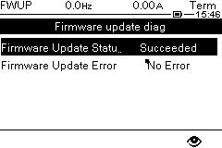
The Update status should indicate Inactive

Resolution

Select Menu 7.3

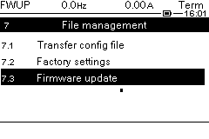
Select Firmware update

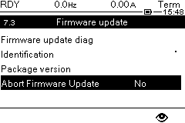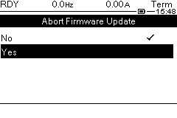
select Abort Firmware Update Select Yes

Then the drive will go to RDY state.

