Answer:

Here is the external potentiometer value vs setting % chart:
(This chart can be found on page 7, refer to RE22 Instruction sheet)

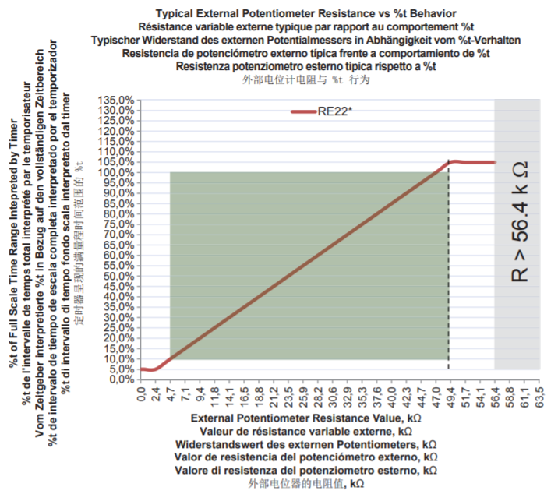

Potentiometer value at 35K ohm, the setting percentage is approximately 75%.

Product marking:

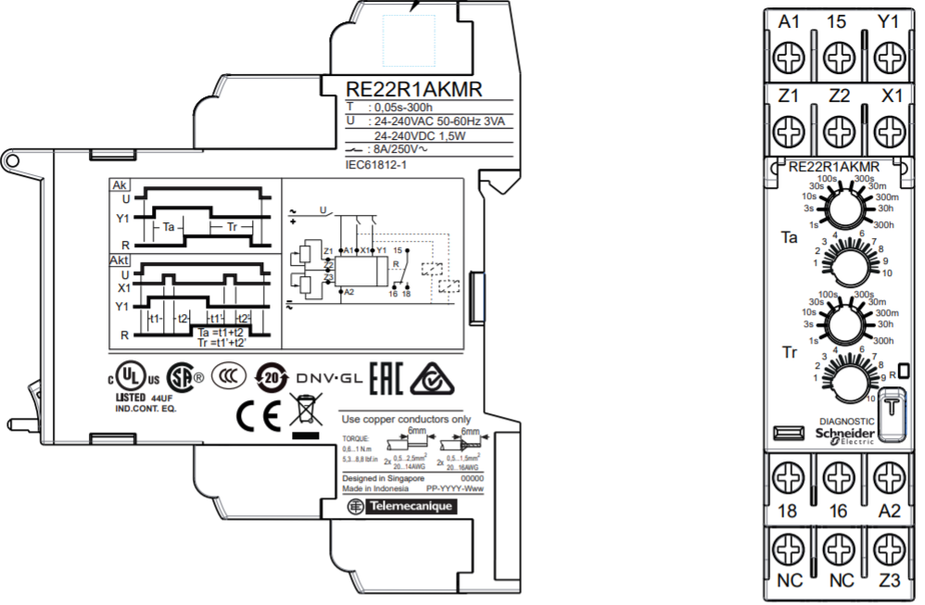
Example:
Time delay range = 100s

So, the Ta or Tr time delay is:

Ta or Tr
= Time delay range x External Potentiometer, 75%
= 100s x 75% = 75s

Example 2: How to configure 80s-time delay, Ta and Tr?

To achieved 80s-time delay, the potentiometer value should be around 37.6K ohm.
Note: Time delay range setting = 100s

Other recommendation:
RE22R1AKMR product is not a high precision product.
For better setting accuracy product. You can consider install our RENF22R2MMW.
Please note that this product doesn’t have external potentiometer connection.
The advantage of this product is the setting accuracy and the can be configure easily using smart phone (Android phone with NFC feature).

FAQs:
FA318932 - RENF Product Identification
https://www.schneider-electric.com/en/search/FA318932

FA318933 - RENF Lock Unlock relay
https://www.schneider-electric.com/en/search/FA318933

FA318934 - RENF Function & Timing selection
https://www.schneider-electric.com/en/search/FA318934

FA318935 - RENF DIAGNOSE Mode
https://www.schneider-electric.com/en/search/FA318935

FA318936 - RENF Cloning
https://www.schneider-electric.com/en/search/FA318932

