TesysU communication registers that gives you information about motor current in Amperes are here below. Devicenet class number : instance number : attribute number for example 68:1:11
- Read register 466 (68:1:11) to get motor current.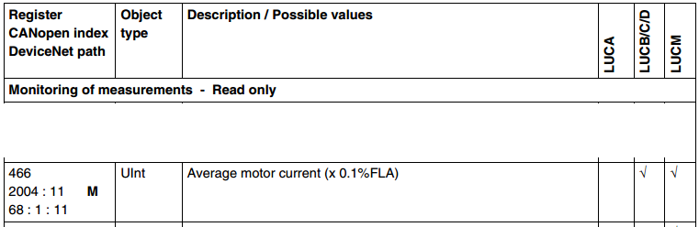This register 466 gives more accurate value that reading motor current from status register 455, because status register uses only 6 bits (bits 8..13) to describe motor current, see below. 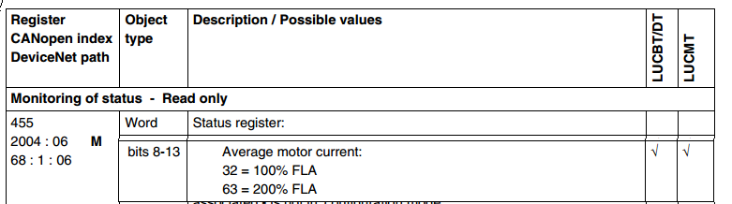
- Read register 652 (6B:1:03) That gives information about FLA setting. The value is in % of FLA max. 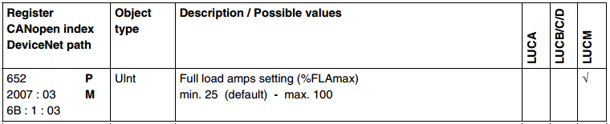
- Read FLA max or consider FLA max as constant value, derived from TesysU hardware. E.g. LUB12 base+LUCM05BL has FLA max 5A. Using LUCM12BL, FLAmax is 12A. So check LUCM reference and if there is no risk that somebody replaces LUCM for different size LUCM, you can consider FLAmax as constant without need to read register 96 (64:1:61) 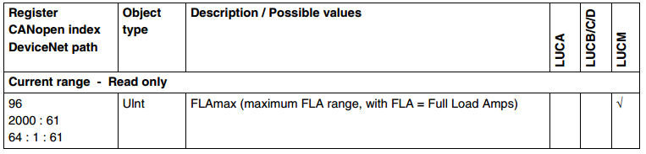
FLAmax defined in register 96 has unit of 0.1A. It means, that if you have 8A, then reg 96 shows number 80 (like 8.0A). So FLAmax shoud be considered as number 80 or as current 8A.
Reg 652 (FLA) is adjusted according to FLAmax. In fact its value is in %. It means 100% represents FLAmax (number 80 in my example). Lets say that nominal motor current is 7A, then reg 652= 86, because 7A out of 8A is 86%
Reg 466 has unit in %, it means, that it returns a value in percent of FLA adjusted. (percent of register 652).
Motor current is interpreted as :
Current (unit = 0,1A) = register 96 * ( register 652 / 100 ) * ( register 466 / 100 ).
Or
Current (unit = 1A) = register 96 * ( register 652 / 100 ) * ( 0.1 x register 466 / 100 ).

In last equation you can see expression 0.1 x register 466. That is exactly as written in manual.
Example:
FLAmax=8A (reg 96 is 80)
Nominal motor current is 7A (652=86)
In case that there is 3.5A to the motor, then 466=50.
To read the average current, 466 has to be multiplied by 0.1 (we get value 5), then divided by 100 (to change percentage into decimal),so we get 0.05.
Next multiply 0.05 with reg 652 divided by 100 (we get 0.05x86/100=0.043) and finally multiply by reg 96, so we get 0.043x80=3.44A.

TO use PKW on devicenet you have to prepare request (PKW out) then you will be given data in response (PKW in). All described in manual
LULC09 DeviceNet
Communication Module
User Manual
10/2007
Extract with all the comments in enclosed file. Double click to open.
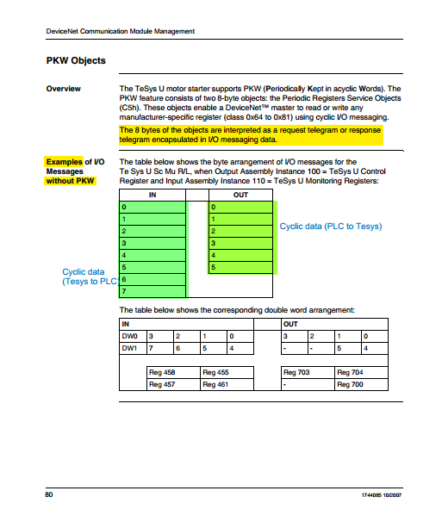
Toggling:
First, prepare all the other bytes (clsaa,, instance, attribute, then set function code + toggle. Function code for reading one 16-bit register is 0x25.
Including toggle bit, the byte 3 will be 0x25 – 0xA5 – 0x25 – 0xA5
Toggling must be done by your program whenever you want to read data.
Best method is to check for response (it returns the same toggle bit). If toggle bit returned is the same as sent, the response is received (and you can toggle again to for sending new request).
Do not forget to check function code in response, which should be the same as function code sent. Otherwise if you receive function code toggle+0x4E it means you got error response and so data in byte 4 and 5 are not the register value, but error code. Possibel error codes on last page in my pdf extract.

