Do Sepam 20/40/60/80 motor protection relays report starting time for even if locked rotor/excessive starting time protection (ANSI code 48/51LR) is not activated?
The answer is YES. Sepam reports starting time even tough users do not enable ANSI code 48/51LR. But there would be a difference in this time measurement. If 48/51LR is enabled the starting time is the time separating the moment when one of the three phase currents exceed “Is” and the moment when all three phase currents drop back below “Is”( Is parameter is set in 48/51LR function). If 48/51LR is not enabled the starting time is the time separating the moment when one of the three phase currents exceed 1.2Ib and the moment when all three phase currents drop below 1.2Ib. Just for information “Ib” is set in Sepam general setting and is named as “Base current”. In motor application for most of the case “Ib” would be the nominal current of the motor .Below Figure will make it easier to understand above explanation.

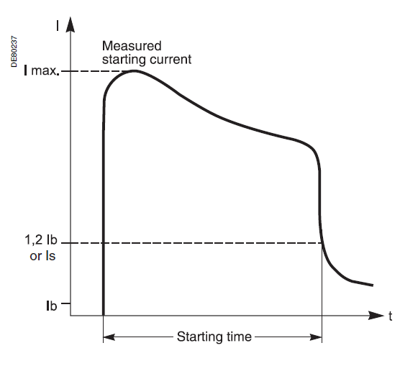

AEDL3

