Here are excerpts from the 61000-5-2 standard from sections 5.3.1 and 5.3.2 along with supporting figures and added notes.

The concept of independent, dedicated earth electrodes (presumably in accordance with
definition 3.14, illustrated by figure 3), each serving a separate earthing network, is a
misconception that not only will not promote EMC, but is a serious safety hazard. In some
countries, national codes prohibit such practice. The use of a separate “clean” electronic
earthing network and a “dirty” power earthing network is not recommended to achieve EMC,
even with the use of a single earth electrode (figure 4). Although not universally accepted,
IEC 61024-1 subclause 3.1.2b) requires bonding “at vertical intervals not exceeding 20 m for
structures of more than 20 m in height. Bonding bars shall be connected to the horizontal ring
conductors which bond the down-conductors”. This arrangement is shown schematically in
figure 5.
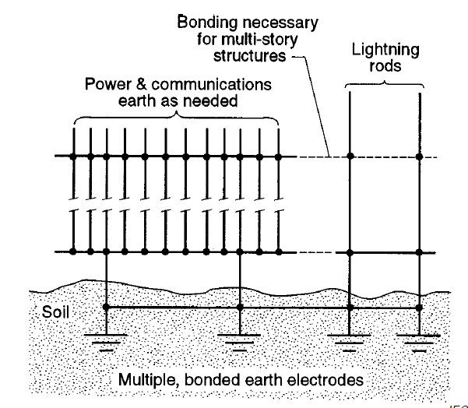
Figure 5.
NOTE: Note that there are many connections to the “Multiple, bonded earth electrodes” in the “Power & communications earth as needed” area. It is in this area that we would separate the power and communications earthing buses within the iMCC.

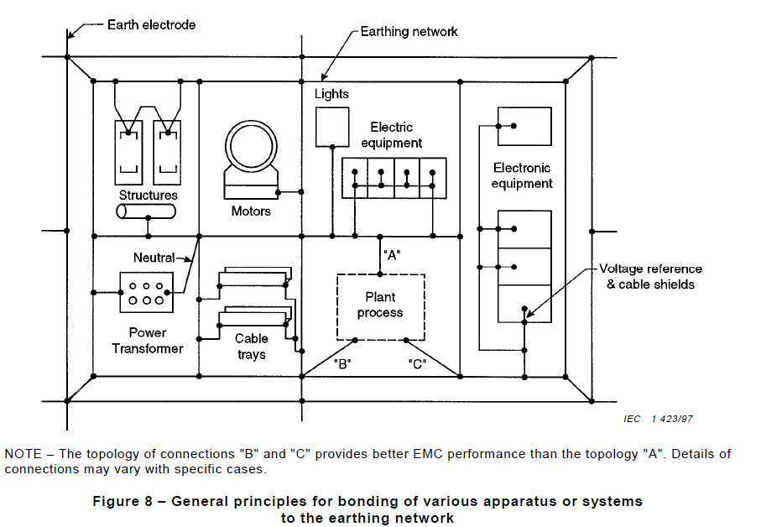
Electronic and communication earthing bus or conductor
Power earthing bus or conductor
Multiple earth electrodes bonded as in Figure 5 to form a grid to create the earthing network.
NOTE: Figure 8 is an elaboration of Figure 5. We do not want the Power earthing bus and the Electronic/communication bus to be the same bus. Yes, they must both connect to the same earthing network and share the same system of bonded earthing electrodes. If the communications shields are connected to the power earthing bus, any noise on the power earthing bus will be introduced into the communications network. It is this point that is being made in the 61000-5-2 standard section 5.3.2 where it is said :

The arrangement of sensitive or high-power apparatus or system to be installed in the building
may require local reinforcement of the earthing network, for example: in control or computer
rooms, near a power transformer, etc. A way to decrease coupling between electromagnetic
interference (EMI) sources and a sensitive device is distance. This principle should be also
applied to the earthing network. Different zones should be created, for example: electronic
zone, machine zone, etc. These zones are interconnected by the earthing network, but layout
of the installation should be such that distance should be as large as possible between sources
and sensitive apparatus or systems as shown in figure 8.

A motor with a potentially large fault current should not be bonded on the same earthing
conductor as sensitive electronics (common impedance coupling should be carefully avoided).
It is recommended to connect the various apparatus at the nodes of the earthing network in
order to improve the EMC performance of the installation.

NOTE: These last two paragraphs from the standard 61000-5-2 occur just before Figure 8. It is not easy to create different zones in a structure such as an iMCC where the power and electronics are mixed. So it is even more important that the grounding buses for the different types of equipment be kept electrically separate until they are connected to the common earthing grid or network.

