Title: How to update the variable by polling when NOP as IEC61850 client
LU Chuizhi 2015-10-26

Apply to:
140NOP85000

Summary:

There are two ways for the variable update in PLC when the NOP as IEC61850 client. One is polling, the other is report. Both of them need to be configured. This application present a configuration steps for the polling.

Solution:

Describe the configuration of Polling for the variable in NOP when it is IEC61850 client.
1. open IEDCT, click client, load scd file.
2. click "IO mapping"\client\parameters, select the variable from the right, then setting "Polling Group"
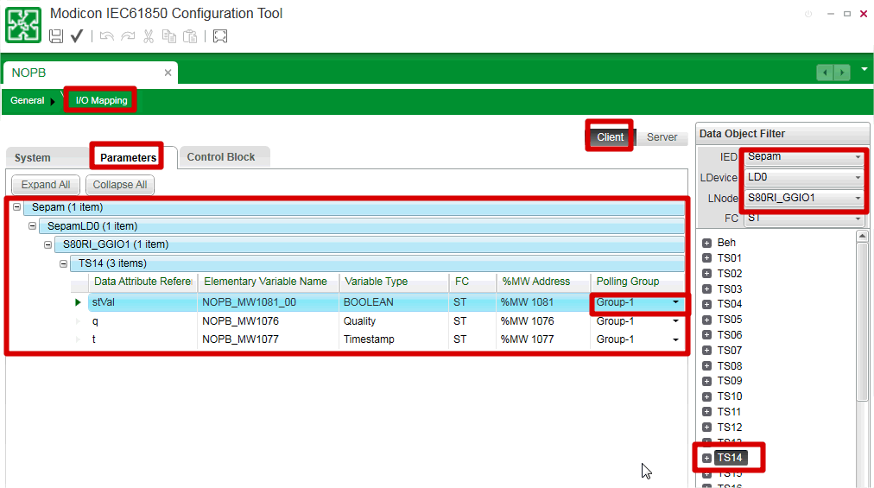
3. save the IEDCT, and close it, "update the application"
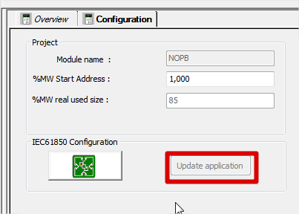
4. you can find the DDT of the polling control DDT
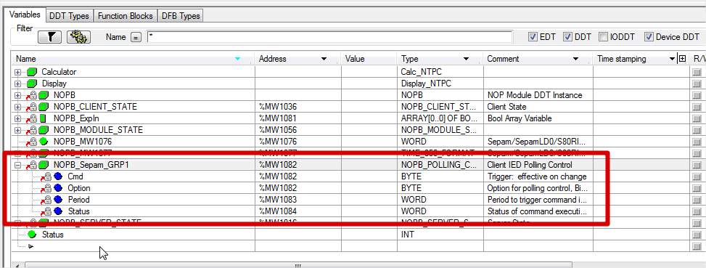
5. Setting the value of the DDT by the user manual's guide
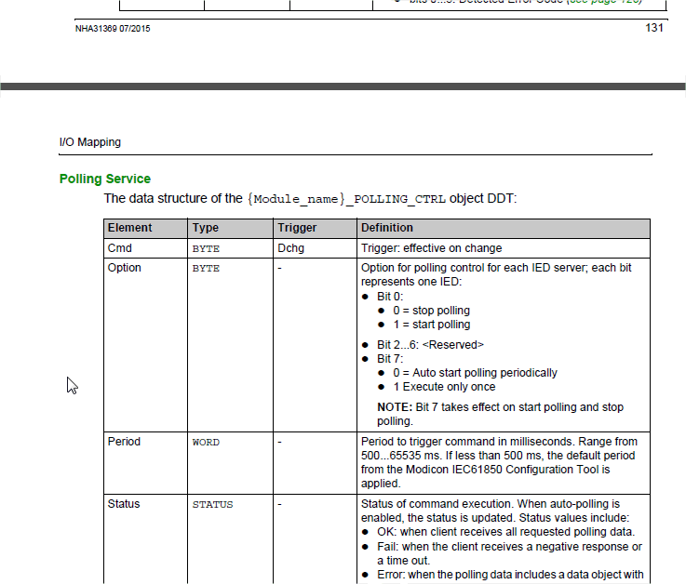

Key Words:
140NOP85000, IEC61850

