Title: How to diagnostic the power supply issue
LU Chuizhi 2015-08-31

Apply to:
CPS, Power supply,

Summary:
Sometimes, there is some issue related to the Quantum Power cycle. Here describe the behavior and the solution in this doc. Here is also the SPEC of the power supply working mechanism.

Solution:
- There are three key lines of the CPS for the backplane power supply: VCC， PWRRESL，POKH；
- The CPS shall monitor the VCC of backplane power supply. If VCC>7V, the CPS will protect itself, the CPS will be locked even thought the short circuit is removed. Power cycle is the only way to resume the CPS；
- The CPS shall monitor the VCC of backplane power supply. If over current is more than 10 seconds, the CPS will protect itself, the CPS will be locked even thought the short circuit is removed. Power cycle is the only way to resume the CPS；
- The “Reset” line is pulled down to ground, “Pwr ok”of CPS’s LED is ON，CPU LCD keep the display and locked，Keyboard and communication are disabled, CPU is frozen; IO “Active” LED is off，the “F” of different IO module had different behavior, ON or OFF; power cycle the CPS, LCD is as following screen.
The humid environment is over range with cause the “Reset” pulled down to ground. User can replace the CPU to another backplane to test, if the “Reset” is released, the CPU can be resumed without power cycle;
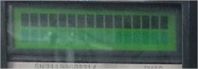
- The “Power_OK” line is pulled down to ground, “Pwr ok”of CPS’s LED is OFF，CPU LCD keep the display and locked，Keyboard and communication are disabled, CPU is frozen; IO “Active” LED is off，the “F” of different IO module had different behavior, ON or OFF; power cycle the CPS, LCD is as previous screen.
The humid environment is over range with cause the “Power_OK” pulled down to ground. User can replace the CPU to another backplane to test, if the “Reset” is released, the CPU can be resumed without power cycle;

- SPEC of CPS output
We record 3 important outputs from CPS 214: VCC, PWRRESL, POKH

VCC: 5V, power supply for whole backplane on this RIO drop;

PWRRESL: Reset LMS ASIC and CPU, IO MCU (e.g. ERT,MCU port 1.1);

POKH: Disable ERT RAM and ROM’s WR;
Critical value of VCC, PWERRESL, POKH for ERT module (different IO module has different critical value)

VCC: 4.5V both Rise and Fall;

PWERRESL: 3.6V Rise, 1.7V Fall;

POKH: 3.6V Rise, 1.7V Fall;
Sequence of power up and fall as follow:
- power up waveform and sequence
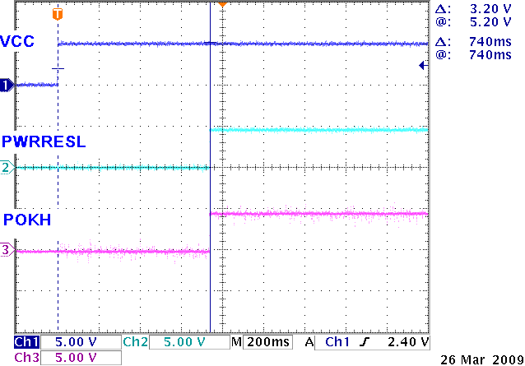

- Power off waveform and sequence
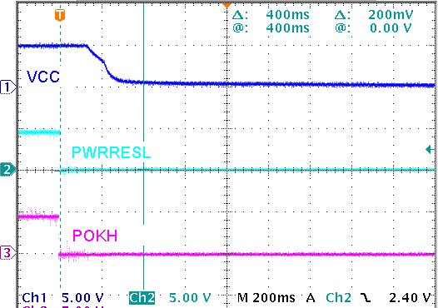
- Test description and result of VCC, POKH, PWRRESL
- Normal working status
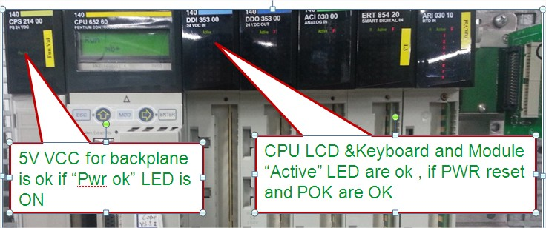
- PWRRESL to GND (Reset backplane)

At Normal State:

CPS no change, its “Pwr ok” is ON; VCC=5.2V for backplane;

CPU dead(no reaction of keyboard, no Comm., …), LCD keeps at the last display;

IO module “Active” is off, “F” is on or off with different IO module(ACI 030 is off, DDO 353 is ON).
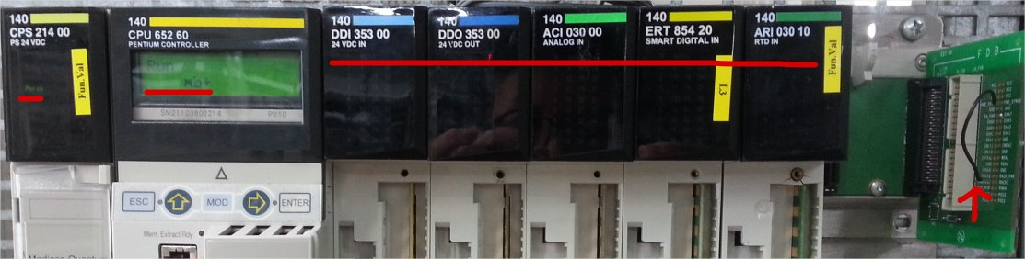

- Restart CPS or power cycle drop:

CPS no change, its “Pwr ok” is ON; VCC=5.2V for backplane;

CPU dead(no reaction of keyboard, no Comm., …), LCD keeps at initialization;

IO module “Active” is off, “F” is on or off with different IO module(ACI 030 is off, DDO 353 is ON).
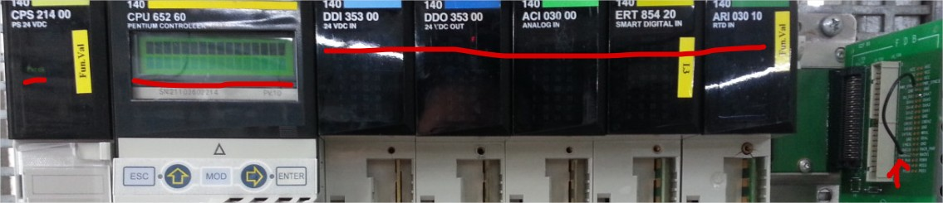
- POK to GND

At Normal State:

CPS’ “Pwr ok” is OFF; VCC=5.2V for backplane;

CPU dead(no reaction of keyboard, no Comm., …), LCD keeps at the last display;

IO module “Active” is off, “F” is OFF
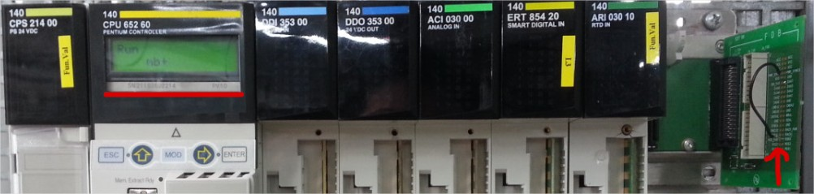
- Restart CPS or power cycle drop:

CPS’ “Pwr ok” is OFF; VCC=5.2V for backplane;

CPU dead(no reaction of keyboard, no Comm., …), LCD keeps at initialization;

IO module “Active” is off, “F” is on or off with different IO module(ACI 030 is off, DDO 353 is ON).
