Title: How to get port diagnostic information from NOP by MSTR

Author:LU Chuizhi
Time: 2016-05-18

Apply to:
140NOP85000, 140NOC78x00

Summary:

User can use MSTR FB to get the port diagnostic information as following

- Get local statistics
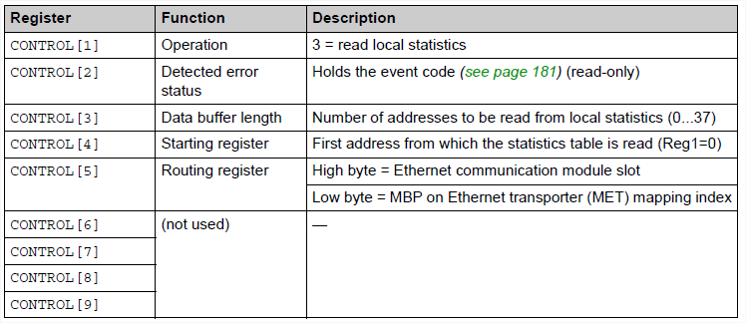
If user want to get the local statistics, the FC=3, start address should be “0~36”, length should be less than 38.

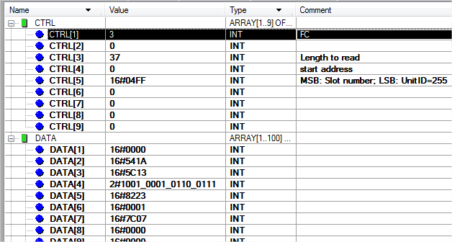

The link status can be read by “Get local statistics” which is including all ports.

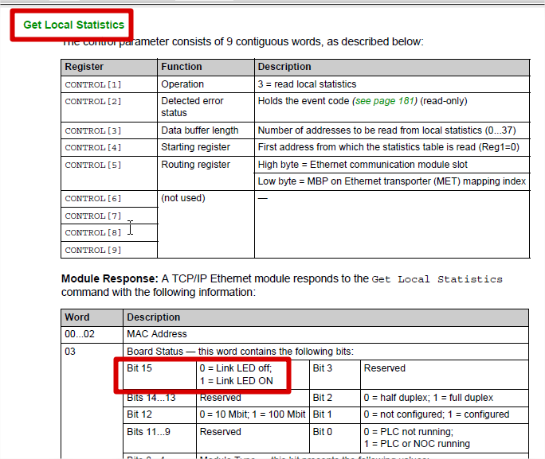

- Read of port diagnostic information
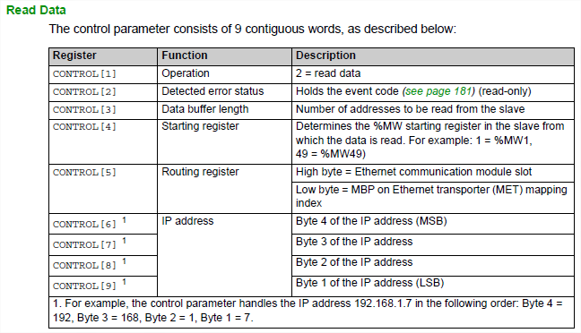
If user want to get the diagnostic information of ports, the FC=2, and the IP address of the module should be configured at CTRL[6]~CTRL[9].
e.g. Read port 1

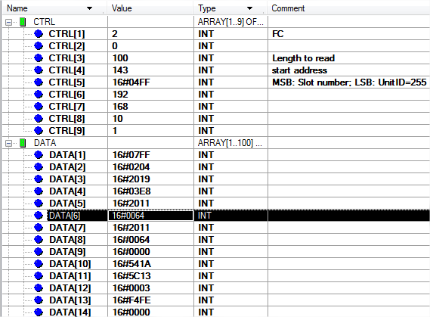

The link status of different port can be read at DATA[7]-bit 13, the following is the example of port 3.
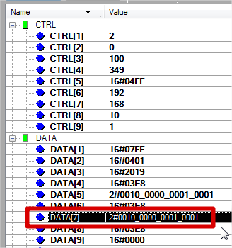

Key Words:
NOP, MSTR, Diagnostic

