Unity pro / Windows 64 bit: fatal error "impossible to find common application path"
Unity Pro / Windows 64 bit: impossible to install HotFix “Registry Key Common AppDate not found”

Error message:
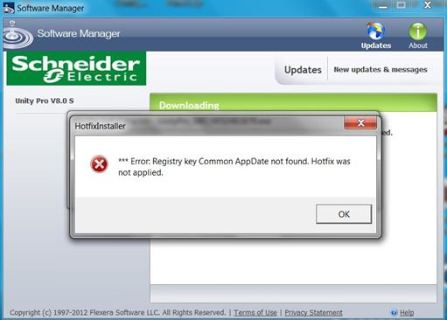

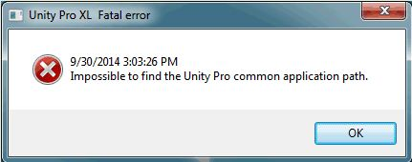
or

For both errors, common ApData key is incorrect or empty in the Registry.
Using regedit,
HKEY_LOCAL_MACHINE\SOFTWARE\Wow6432Node\Microsoft\Windows\CurrentVersion\explorer\Shell Folders\
Common AppData. Assign it the value: C:\ProgramData

Just below is a registry file to perform the required modification.

