Environment – 1 :
- Install Unity Pro 8.0.

- Install “PSx General Purpose Library for Unity Pro”.
Note : This Library is compatible with Windows 7 OS.

- Open UnityPro 8.0 Tools Types Library Manager. Find “PSx General Purpose Library for Unity Pro” available.
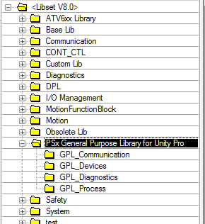

- Right click on “GPL_Communication” Create Installable family
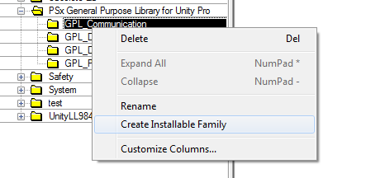
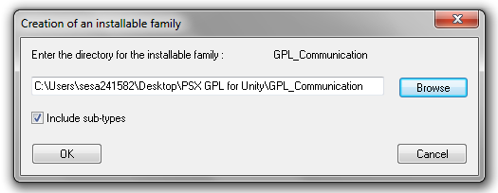
NOTE : Always select ‘Include sub-types’.
Save in a folder : - Output of this shall be
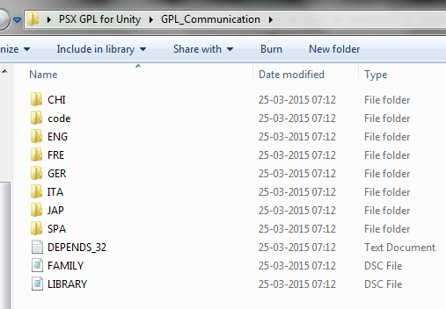
Similarly create installable family for all the families “GPL_Diagnosis”, GPL_Process”, “GPL_Devices”.
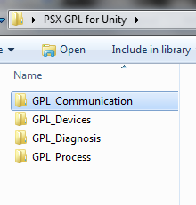
Environment 2 :-
- Install UnityPro 8.1.
Note : While installing UnityPro 8.1 request you to go through Readme of UnityPro 8.1. There are few mandatory steps to be followed if user is installing UnityPro 8.1 on Windows8.1 OS.

- Copy all the Installable folder created on UnityPro 8.0 machine.
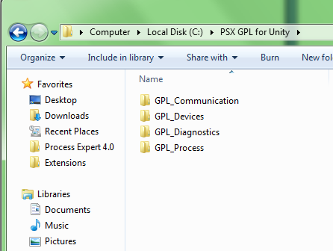
- Open Types Library Update tool of UnityPro
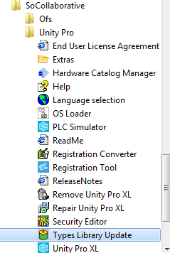

- Browse to the Installable folder and select the “Family.dsc” file.
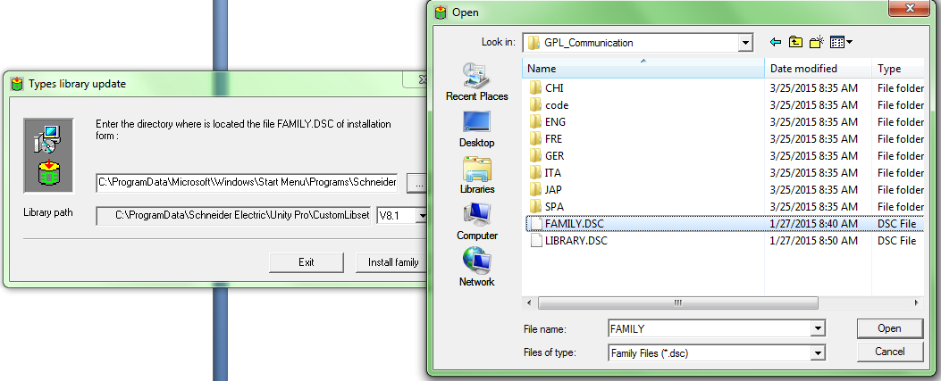

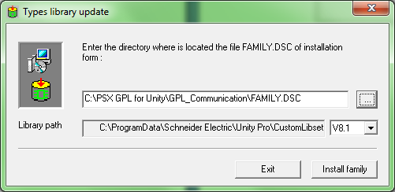

- Click on Install Family.
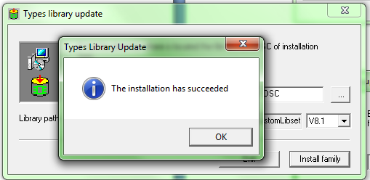

- Follow the same for other all the families “GPL_Diagnosis”, GPL_Process”, “GPL_Devices”.

- Open UnityPro 8.1 Tools Types Library Manager.
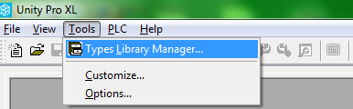

You will find “PSx General Purpose Library for Unity Pro” families available.
