To force the USB keyboard in AZERTY, please perform the following steps:

- Disable the 'EWF
- Copy/Paste the file “Clavier_FR.reg" on your target (anywhere)
- Restart the target
- Execute the file "Clavier_FR.reg"
- Click ‘Yes’ on the following message
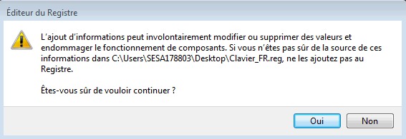Une

6. Once the update done, click ‘Yes’ on the following message:
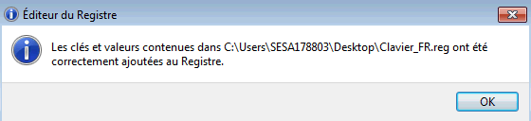

7. Enable the EWF and restart the target
8. Launch the Run Time, you can notice that we have no more the issue and the keyboard is well detected in AZERTY, in any cases.

9. If you want to come back to the original configuration, you have to perform the same actions with the file "Clavier_Original.reg" (optional).

