DATE: September 23th 2014
TO: Internal
Resolution

& intermediate workaround

SUBJECT: Automation systems, Modicon M340 PAC (Programmable Automation Controller) range BMXP34xxxx frozen at start-up

- Introduction

An issue has been identified with the BMXP34xxxx CPU references whereby the processor remains in stop mode (with the “ERR” LED illuminated) after performing the self test function at start-up.

Products impacted:

Product name | Designation | PV | SV
BMXP341000 | CPU340-10 MODBUS | 13 | 2.50 or below
BMXP341000H | H CPU340-10 MODBUS | 7 | 2.50 or below
BMXP342000 | CPU340-20 MODBUS | 9 | 2.50 or below
BMXP3420102 | CPU340-20 MODBUS CANOPEN2 | 8 | 2.50 or below
BMXP3420102CL | M340 20102 CPU - CardLess | 4 | 2.50 or below
BMXP342020 | CPU340-20 MODBUS ETHERNET | 13 | 2.50 or below
BMXP342020H | H CPU340-20 MODBUS ETHERNET | 9 | 2.50 or below
BMXP3420302 | CPU340-20 ETHERNET CANOPEN2 | 8 | 2.50 or below
BMXP3420302CL | M340 20302 CPU - CardLess | 4 | 2.50 or below
BMXP3420302H | CPU340-20 ETHERNET CANOPEN2 | 8 | 2.50 or below
BMXP3420ITRB | CPU340-20 Data Center Mgt | 7 | 2.50 or below
BMXPRA0100 | Peripheral Remote IO | 7 | 2.50 or below

- Description of symptoms:
When the CPU is powered up, it goes into the regular self-test mode. During the self-testing the CPU becomes frozen with the LED indicator «ERR» illuminated, as shown below:

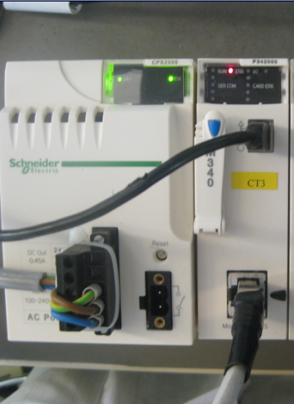

LED indicator «ERR» illuminated

The CPU is now locked up with no ability to communicate. Cycling the power supply of the CPU will not unlock the unit.

- The root cause
Following a PLC failure, due to PLC structure malfunction, the processor BMXP34xxxx restarts.
At this start-up, the “failure information” or “crashlog file” about the initial failure is stored on the SDCARD and internal memory flash.
A second failure of processor appears (CPU Frozen), due to an incompatibility between new generations of internal flash memory that were recently implemented (see PV of impacted products list) and the flash memory access algorithm.

- Solution
A new firmware version will allow start-up of BMXP34xxxx after a failure (SV2.60).
This version will be available at the beginning of October 2014 on Schneider-Electric.com.

Important: Root cause of initial failure that generated a crashlog file is not fixed in the V2.60 version. So it is important to explain to the customer that after the new FW version implementation, the CPU can fail again and in this case it will be necessary to send crashlog file to technical support, in order R&D experts can find root-cause.

- Description of work-around: to unlock and restart CPU frozen.
If the version of BMXP342xxx cannot be changed at the customer’s site, it is possible to force the CPU to start.
- This workaround will allow the CPU to be unfrozen.
- Take care, if the CPU fails again, the same “workaround” should be done.
- Resolution is to download new FW version (end of September) and send the crashlog file to Technical support.

Operating principle of the workaround:
Transferring an application will remove the crashlog file backup at next startup.

Step 1
- Switch OFF the frozen CPU.
- Remove the SD card.

Step 2
- Switch ON the frozen CPU.
- Wait for LED indicator «CARD ERR» to be steady on and LED indicator «ERR» to be blinking.
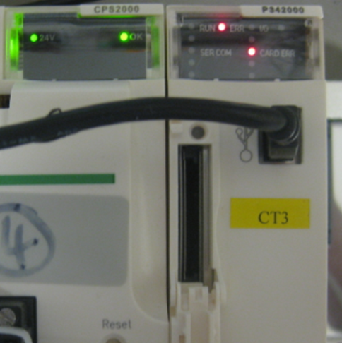

Step 3
- With the SD Card removed, transfer the PLC application from a PC to the PLC using the USB connection port.
- Put the PLC into “RUN” mode.
- Wait for the LED indicator «RUN» to go green and LED indicator «CARD ERR» to go red (both steady on).
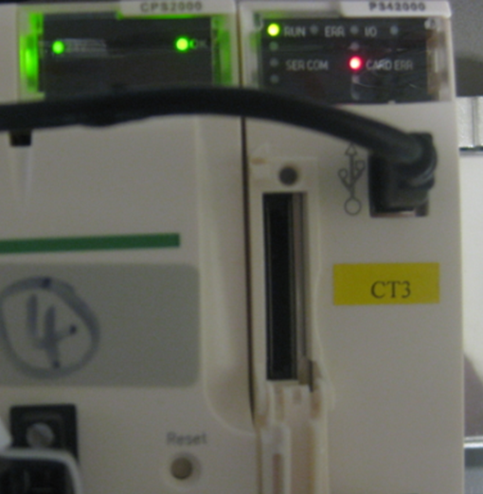

Step 4
- Switch OFF the CPU.
- Insert the SD Card.

Step 5
- Switch ON the CPU.
- Repeat the application transfer from a PC to the PLC using the USB connection port.
- Wait for the LED indicator «RUN» to go green and the LED indicator «CARD ERR» to extinguish.
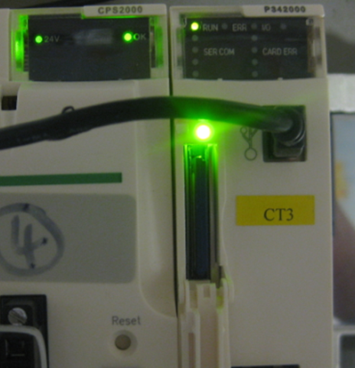

The M340 processor module is now unlocked and available to run.

