Title: How to read data from X80 NOM using MSTR with func15

Author: WANG Qian
Time: 2015-05-07
Summary: How to use MBP_MSTR block with function code 15.
Keywords: MSTR, NOM,modbus,X80

Content:

Use MBP_MSTR block with operation 15 (Send Modbus request) to send following request to the CRA to read registers through NOM in remote drop.
The request and positive answer are like below shown:
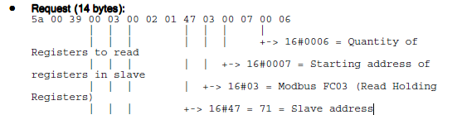
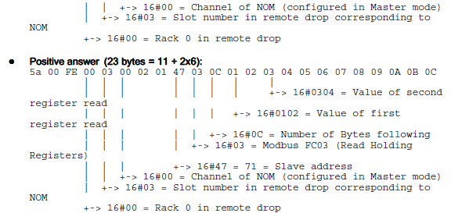

The "Control" of MBP_MSTR is like below shown:
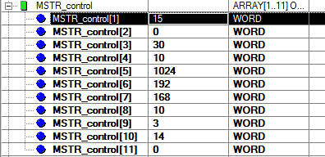

The Data[1]-[7] are the modbus request, it will be send to modbus slave target, and then the modbus target will response back the data in Data buff starting at Data[11].
