How to activate the local remote key on the remote keypad
At first show that the drive is ordering via the terminal
On the first menu

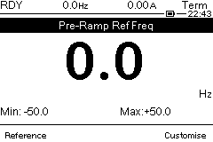

Term: inform that the drive is ordering by the terminal
RDY is the status of the drive
0.0Hz: AI1 reference speed
Local remote key on the remote keypad is disactivated.

On the first menu
Action: Set a speed reference with AI1=20%

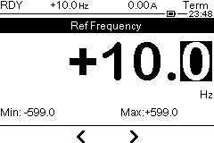

On the first menu
Action: SET Di1=1
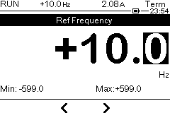
RUN means that the motor is running at 2.08 A by the terminal
The current is 2.09 A in the motor

On the first menu
Action:SET DI1 = 0

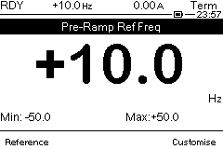
RDY is now the status of the drive
10Hz is the reference given by AI1

now how to order via the remote keypad
Action:Press ENTER key
Main menu is now present
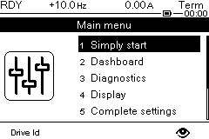

Action: Select and press Enter on the Complete settings

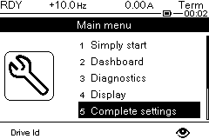

The new menu is: complete setting
Action: Select the sub-menu 5.4 command and refere

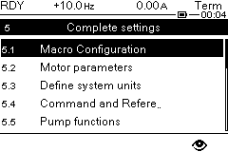
Action: Press ENTER on Command and Referen sub-menu
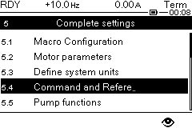
The new sub-menu is Command and refere

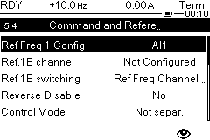
AI1 means that the reference is given by AI1
HMI cmd is always is in disabled state

Action: Select HMI cmd parameter with the dial

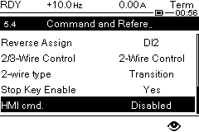
Action: Press ENTER on HMI cmd parameter

New menu HMI cmd.

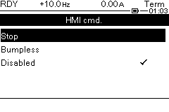
HMI cmd is disabled

Action: Select and press Bumpless sub-menu

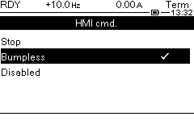
Now HMI cmd is activated on bumpless.
The local remote key is now activated.

On the first menu

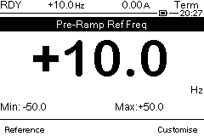
Term is always present

On the first menu
Action: Press local remote key present on the remote keypad to switch from TER to HMI.

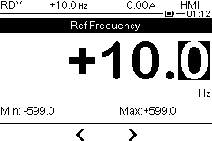
AI1 reference is copied to HMI reference
HMI is now the new command of the drive

Action: Press RUN key present on the remote terminal

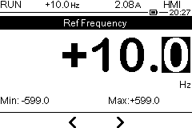

RUN means that the command is coming from the remote keypad

Action: Press stop key

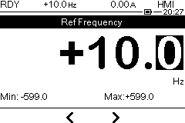 key
RDY is the state of the product

Action: Press local remote key

HMI is switching on the terminal

