Answer:

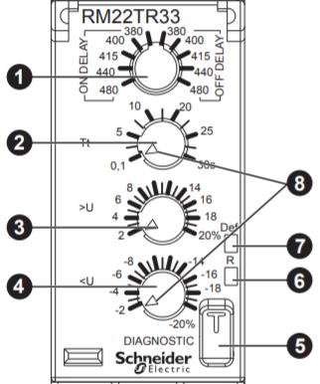
Example:
- Voltage range = OFF delay, 380V
- Time delay adjustment potentiometer Tt = 5s
- Overvoltage setting potentiometer, >U = 8%
>U = 380V + (380V x 8%) = 410.4V

- Undervoltage setting potentiometer, <U = 8%
<U = 380V – (380Vx8%) = 349.6V

>U = 410.4V
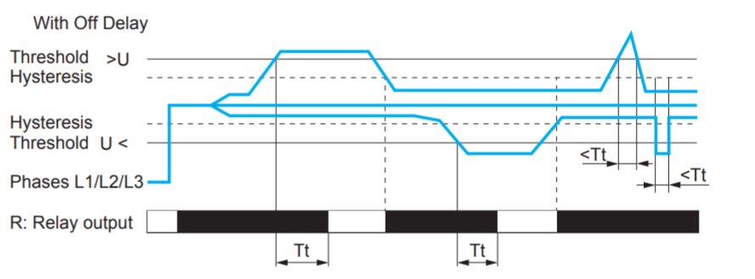
>U = 349.6V

RM22TR33 product’s “Setting accuracy of the switching threshold” is +/- 10 % (full scale). This information is recorded in product data sheet.

Setting Accuracy = ±10% (full scale value)
Voltage range = OFF delay, 380V

>U, Voltage Threshold with setting accuracy tolerance = 410.4 +/- (380 x 10%) = 372.4V to 448.4V
<U, Voltage Threshold with setting accuracy tolerance = 349.6 +/- (380 x 10%) = 311.6V to 387.6V

