Case 31146496: Sepam 80 “Pulse” Mode for Logic Outputs (e.g., O1 or O101)

Last Updated: September 9, 2016

The information presented here applies to the Sepam 80 relay with V9.0x firmware.

Regarding the “Pulse” mode for Sepam 80 Logic Outputs, there are a few points to note.

1) For Output O1 (almost always used for the CB Trip output), the pulse length can only be adjusted if “Pulse” mode is selected. Otherwise, it is 200ms by default, if the CB Control built-in standard logic is used.

2) For Output O1, the pulse length can be set from 200ms (minimum) to 300s, as explained in the Sepam manual.

3) For other outputs on the MES120 I/O cards, the behavior is slightly different. For outputs like O101 and O102, the default pulse length is 300 milliseconds, if Pulse Mode is enabled as shown below in SFT2841.

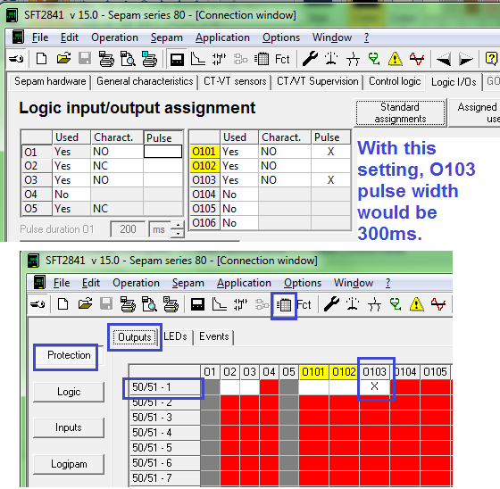

4) If a specific Pulse Width is required for outputs such as O101 or O202 (on the MES120 modules), then a Ladder Logic (Logipam) diagram or Logic Equation can be used. The image on the next page shows one possible way to do this.

As shown, one possible way is to use a TON Timer, which will be put in series (“AND” condition) with the signal that triggers the outputs. As shown below, the desired outputs will only be energized for the length of the TON timer. As shown in the second image, please remember to check the LOGIPAM delay settings in SFT2841. Sometimes they do not update correctly when the Logipam program is loaded for the first time.

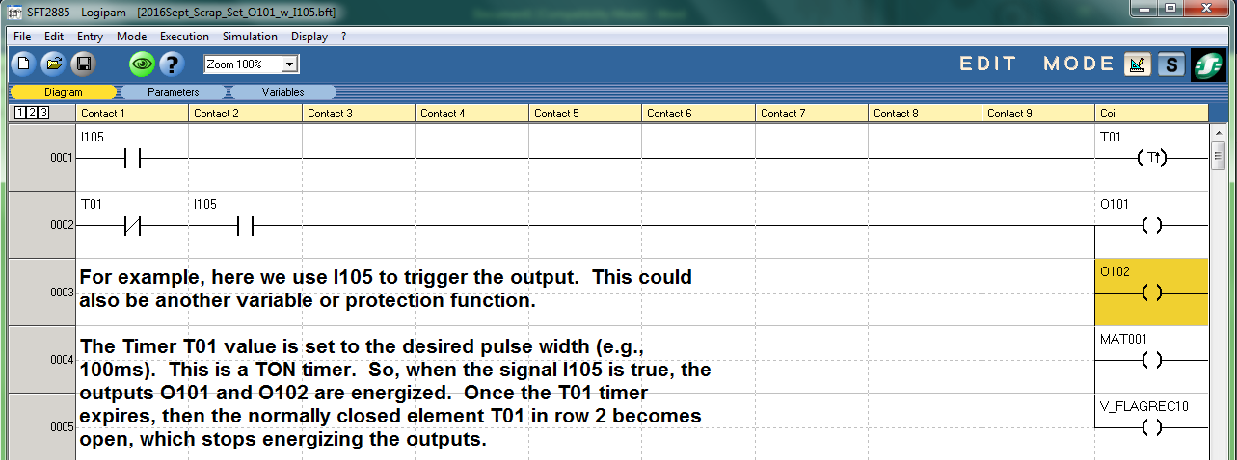

As shown below, please remember to check your LOGIPAM timer settings in SFT2841 if you find that the Timer is not working correctly.

