Sepam ACE850: How To Access Web Server Diagnostic Pages With Java Version 6

Last update: 2015-Jun-22 by JSU

The Sepam ACE850 Ethernet module provides various Diagnostic pages which allow the user to view important information such as the status of the GOOSE messages (both for transmission and reception) and the status of the SNTP time synchronization.

The screen capture below shows an example of the GOOSE Messaging Statistics page.

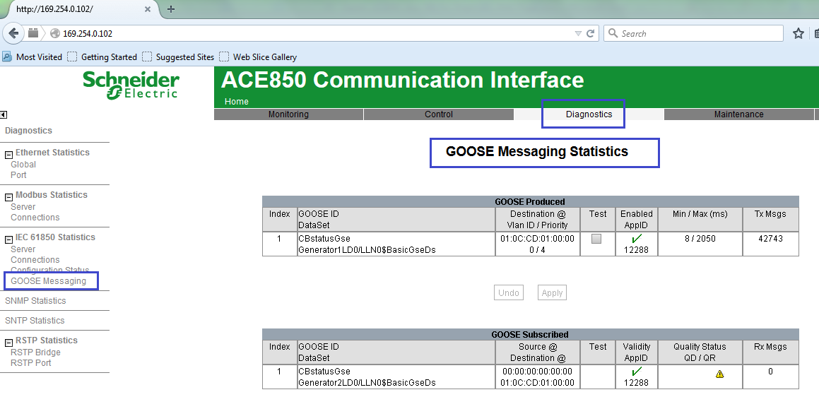

Due to recent security updates that have been made to the most commonly used browsers such as Internet Explorer and Google Chrome, the Java plug-in that is embedded within the ACE850 web pages will be blocked or disabled for a large number of users.

This document gives an example of how to work around this issue using the Mozilla Firefox browser. The version of Java required to access the ACE850 web pages is also given.

1. Java Version Required to Access ACE850 Diagnostic Web Pages

At the time of writing of this document, the latest ACE850 firmware version is as follows:
V2.2.20019

The ACE850 firmware version can be checked by using the ACENet Tool. You must establish a TCP/IP connection between your PC and the ACE850, and then use the ACENet Tool (which is available from the a public FTP site hosted by Schneider Electric) to poll the device.

If the embedded Java plug-in inside the ACE850 module is updated in a later firmware version, the contents of this document may no longer be applicable.

For the ACE850 firmware version given above, the required Java version to be installed on the client computer is Java 6 (Update 6). If this component is installed on your computer, the Java Deployment Toolkit 6.0.260.3 should also be installed. If both of these are visible as add-ons in your web browser, then you should have the correct Java version.

The Java 6 (Update 6) installer for 32-bit Windows operating systems can (at the time of writing) be downloaded from the internet. If you have trouble locating it, please contact Schneider Electric support for assistance. A link is provided here for your convenience, but it may expire in the future.

https://schneider-electric.box.com/s/v859wfliq5awvcrscqw2yidirvmrveym

2. Workaround to Allow ACE850 Java Plug-in to Run

Once the required Java version has been installed, the user will likely need to adjust additional security settings in order to enable it to run. In this document, a procedure that has been successfully used with the Mozilla Firefox browser will be described. The choice of this browser was made simply because the relevant security settings are more convenient to adjust in Firefox compared to browsers such as Internet Explorer or Google Chrome.

Suggested Steps to Enable Java 6 (Update 26) Plug-ins:

1. For simplicity, you may wish to un-install any other Java versions, such as Java 7, or Java 8. If your browser attempts to use a Java version other than V6 to run the ACE850 web pages, then the pages will not load correctly.

2. After installing the Firefox browser, it is suggested that you re-install the Java 6 (Update 26) component. This Java version should then be visible in Firefox as an Add-On.

3. Next, please follow the instructions given below. The link to the original source page is also given, but it may expire.

https://support.mozilla.org/en-US/questions/924629

a) Open a new Tab
b) Navigate to about:config
c) Accept the security warning
d) Change extensions.blocklist.enabled to false
e) Restart your browser

This prevents firefox from checking the blocklist you have configured at extensions.blocklist.detailsURL

4. As shown in the screen capture below, you should now be able to navigate to about:addons and make sure that the Java Platform and Java Deployment Toolkit add-ons are set to “Always Activate.”

If you had tried to do this before performing the previous step, you would have seen that the “Always Activate” option was grayed out. This is because Java add-ons have been added to the “Blocked List” for the Firefox browser.

In the about:addons page, if you have enabled the 2 Java V6 components as shown below, and ensured that any other Java versions are either disabled or uninstalled, you should now be able to connect to your ACE850 module web server and access the Diagnostic pages.

