Sepam 80: How to Record MET148-2 Temperature Readings During a 38/49T Trip Event

Related Products: Sepam 80, firmware V8.xx up to V9.xx
Latest Update: April 2016

Issue Description

Sepam relays provide “Trip Context” information whenever a Protection Trip occurs. The Trip Context information can be retrieved using the SFT2841 software or via communication and it records values such as Phase Current, Residual Current, Voltage Symmetrical Compoments, and Differential Current.

However, for the present versions of SFT2841 software (V15.1) and Sepam 80 firmware (V9.01), the temperature values recorded by the MET148-2 module are not logged in the Trip Context.

The image below shows the Alarms screen in SFT2841 after a 38/49T Protection Trip has occurred:

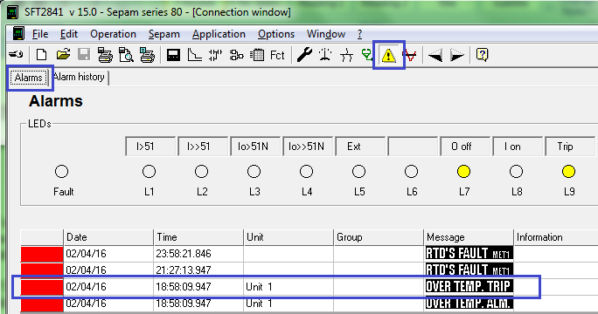

The next image shows the Trip Context screen, with the 38/49T Trip selected from the drop-down list. Notice that the MET148-2 measurements at the time of the trip are not displayed.

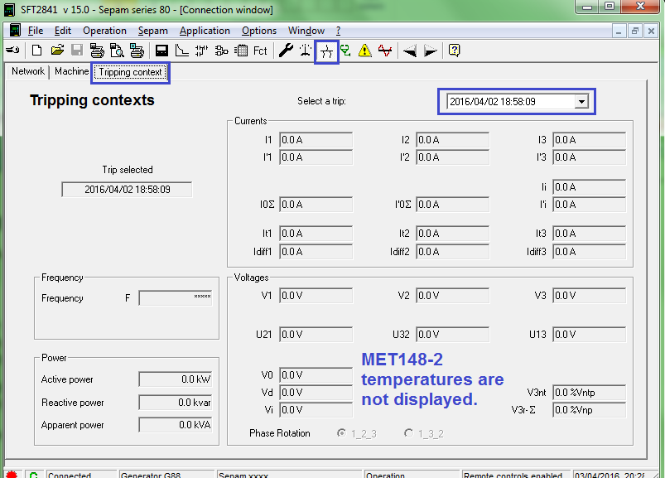

Resolution

In order to record the MET148-2 temperature values from the time of the trip, one possible solution is to use the Data Log feature which has been added to the Sepam 80 range starting in the V8.01 firmware version.

As explained in the Sepam User Manual, the Data Log function allows the user to select a number of parameters which can be logged to a COMTRADE file. As shown in the screen capture below from SFT2841, there are a number of different methods provided to trigger a new recording, and the choice of which values to log is made in the same screen.

The example settings below should allow you to capture the MET148-2 measurements immediately after a 38/49T function trip. A simple Logic Equation (or Logipam program) is also needed to trigger the Data Log recording.

Start/Stop: Choice by equation or Logipam
Recording Mode: Limited
Duration and Sample Interval: Can be set as desired, but 1 second is the smallest interval
Selected Data: ensure that the relevant MET148-2 values are added to the Selected Data section.

The following line should be added to the Logic Equations in SFT2841. The example below assumes that only Unit #1 of the 38/49T function is used to trigger the Data Log. You can create a variable and add “Logical OR” conditions if you want to trigger the Data Log using other units of the 38/49T function as well.

V_DLG_START = P38/49T_1_3

Please see the following page for an example of the output of the Data Log.

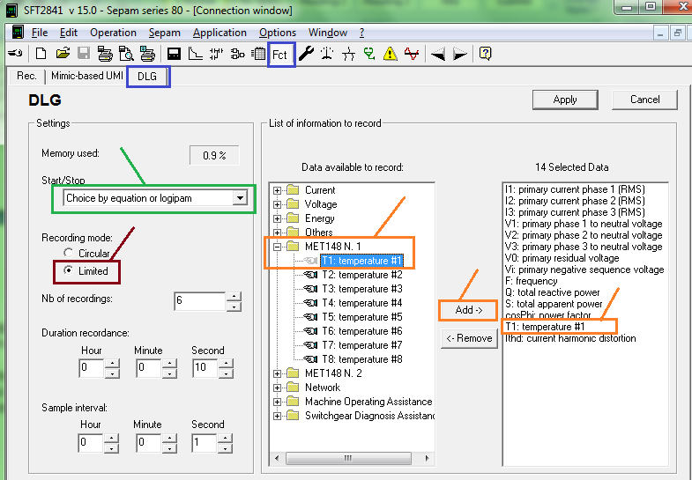

The image below shows the Data Log list in the relay with SFT2841 in Connected Mode. This data log has been generated during a test where a 38/49T trip was used to trigger a new data log recording. As shown, a record can be selected by clicking on it, and then by clicking on the “download” icon.

The numerical values in data logs are published in COMTRADE files. These files can be viewed with software such as OMICRON’s Transview software, or Schneider Electric’s WaveWin software.

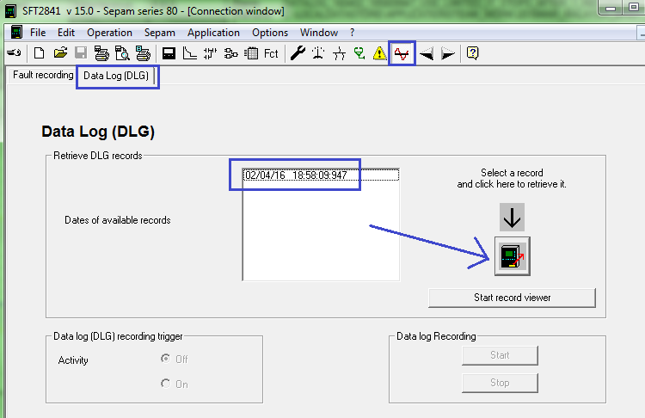

As shown in the example screen capture from the OMICRON Transview software, the Data Log Record contains the temperature value recorded over a period of 10 seconds with a sampling interval of 1 second. The temperature value at the time of the trip has been captured, and thus we have achieved the objective set out in this resolution.

