Case 24543910: Sepam 80 ANSI 25 – Brief Notes About Settings and Usage

This file contains a brief overview of how the Sepam MCS025 module should typically be used and configured. Please contact Schneider Elecrtric Technical Support if you have any further questions about the contents of this file.

1. Typical Applications for the Sepam MCS025

In our experience, the MCS025 is commonly used to synchronize Generators to a network which may also be supplied by another source (please see diagram below). Another common usage is for the “2 out of 3” auto-transfer application, when the MCS025 is used to verify that the voltage on either of the Incomers is synchronized with the voltage on the Busbar before allowing the 2 Incomers to be connected in parallel.

The “Closing With Synchro-Check” option in SFT2841 may be used to ensure that Sepam will only execute a “CB Close” command if the Close Enable signal coming from the MCS025 is in the “TRUE” state. In this case, the “Auto-Transfer” control logic does not have to be used.

The MCS025 simply takes 2 single-phase input voltages and measures the differences between these voltages with regards to the following parameters. If the differences are within the limits set in SFT2841, the Close Enable output contact will be closed.

- magnitude of the voltage
- frequency
- phase angle
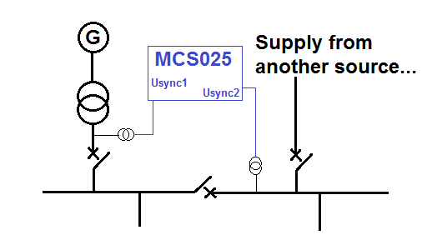

2. Physical Installation of the MCS025 Module

The document at the internet link below gives an overview of how the MCS025 module should be installed in the cubicle.

http://www2.schneider-electric.com/library/SCHNEIDER_ELECTRIC/SE_LOCAL/APS/191270_500A/63230-216-244_MCS025__InstallSheet.pdf

3. Required Settings in SFT2841

a) the first step is to ensure that your physical wiring connections for the MCS025 are correct, and then to enable the MCS025 in SFT2841 for the base unit to which it is connected. This is shown in the image below.

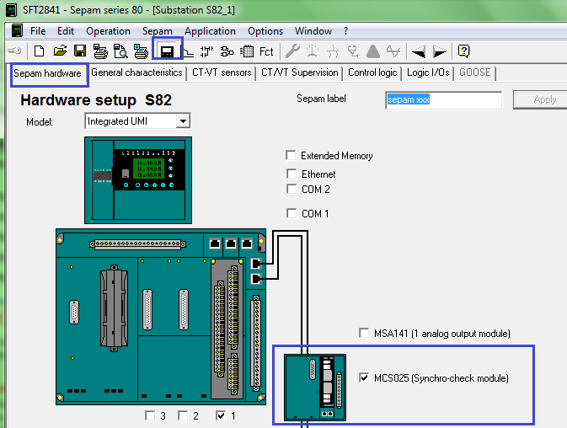

b) if you want to force Sepam to check for the “Close Enable” signal before executing any “Close CB” commands, you can check the option shown in the image below (Control Logic tab). This can be done, for example, if you are not using any Auto-Transfer logic, but your Sepam is protecting a Generator and you want to ensure that it is synchronized to the network before closing the breaker. You must also ensure that the ANSI 25 function is enabled (pls see below).

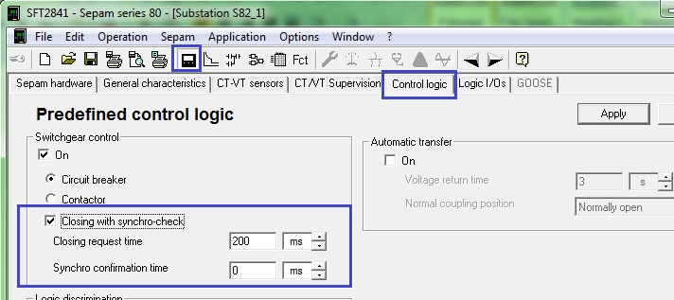

c) Ensure that the “ANSI 25” protection function is enabled as shown below. Otherwise, the “Closing With Synchro-Check” option described above will not work.

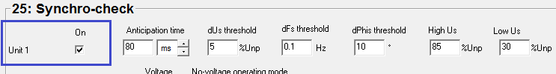

d) Finally, the parameters for the ANSI 25 function should be set. The thresholds for differences in voltage (dUs), frequency (dFs), and phase angle (dPhis) allow you to define the conditions for which you will consider that the synchronization is successful. For example, if the difference in voltage magnitudes is more than 5% of the Nominal Voltage defined in SFT2841, then the MCS025 will not turn on the “Close Enable” signal, and so on.

The “High Us” and “Low Us” parameters allow you to define a valid range for the Usync1 and Usync2 voltages. A voltage is considered to be present and valid as long as it is higher than the “High Us” percentage. If one of the input voltages is less than the “Low Us” value, then it is considered to be “absent” or “dead.”

You can use the “Voltage Check” option if you want to allow closing in certain situation when one of the Usync1 or Usync2 voltages may be absent.

For example, as described in the user manual, if you enable Voltage Checking and select “Dead1 and Dead2,” then the Close Enable will turn ON if both voltages are absent.

The setting values shown below are fairly typical based on our experience. However, you may have data from a consultant or Protection Study that you can refer to for these settings.

Regarding the “Measured Voltages” section, this simply allows you to define if the voltages wired to the MCS025 are phase-to-neutral or phase-to-phase voltages. The VT secondary values should be entered so that the MCS025 can calculate the acceptable range properly.

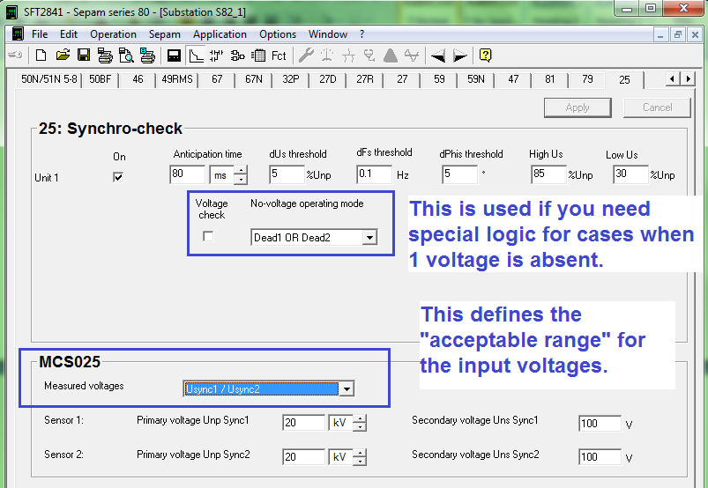

4. Other Points to Remember

a) note that the MCS025 takes only 2 single-phase input voltages. This can be a phase-to-ground, or phase-to-phase voltage, but it must be the same type of voltage for both the Usync1 and Usync2 inputs.

b) the 2 voltages Usync1 and Usync2 should ideally be taken from the same “voltage level” in the substation. So, the voltage transformers should be installed at the same voltage level, and then the VT secondary outputs should be connected to the MCS025 inputs.

c) as of Sepam 80 firmware version V8.xx and SFT2841 version V15.0, there is no function to display the real-time voltages measured by the MCS025 module itself. With SFT2841 in Connected Mode, you can view the differences measured by the MCS025. However, as far as the actual voltages measured for Usync1 and Usync2, these are not displayed in the SFT2841 “Measurements” screen. This can be a relevant point during commissioning tests, when the main VT inputs of the Sepam could be wired correctly, but the wiring to Usync1 and Usync2 could be incorect.

