Answer:

Both the RM22JA31MR and RM22JA31MR SP01 product having similar specification except the function diagram.

RM22JA31MR , Function diagram >>> Positive Logic.
RM22JA31MRSP01, Function diagram >>> Negative logic.

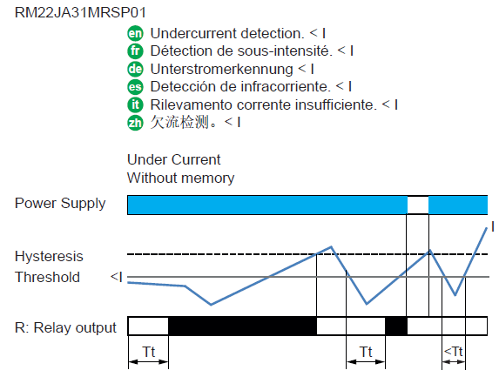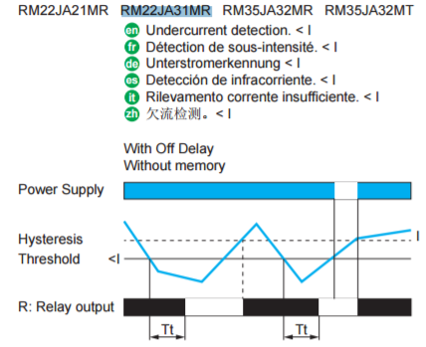

Notes:
The behaviour of the output relay signal is different.
Please refer to the instruction sheet for more detail information.

