Answer:

How to configure the RM22UA33MR product to monitor overvoltage 300V and undervoltage 230V?

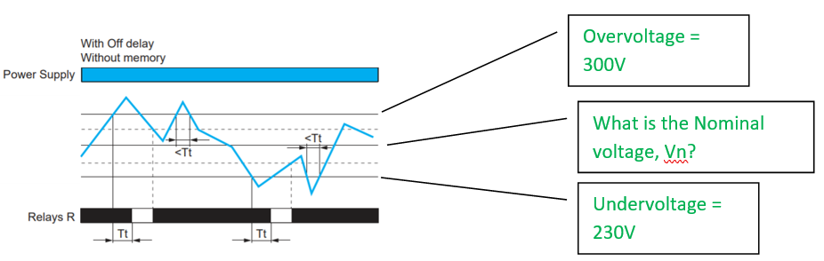
Vn
= [(Overvoltage – Undervoltage) / 2 ] + Undervoltage
= [(300V – 230V) / 2 ] + 230V
= 265V

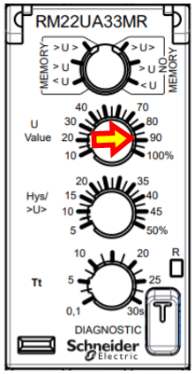
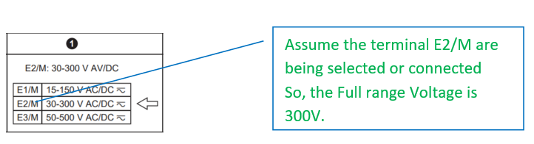
To set U value (%)
= (Nominal Voltage / Full range Voltage) x 100%
= 265V / 300V x 100
= 88.33%

Next step, how to configure Overvoltage = 300V and Undervoltage = 230V?
Configure operating mode to >U>, No memory.

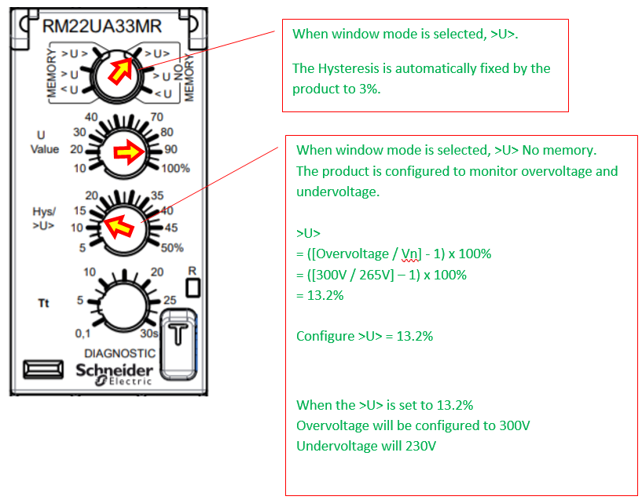

Note:
Please note that the RM22 product is not a precision measurement device.

