Dear Collegue,
First of all, according the Serviceability policy attached from local adaptation team, the end user is not allowed to adapt transfer switch equipment. The adaptation is classified A5!!!!
As per BU local adaptation team and they confirmed that such adaptation is mainly allowed only by local adaptation center.
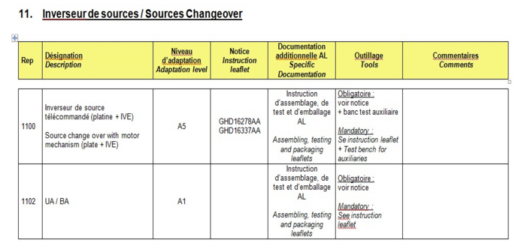
For fixed and drawout version the safety trip interlock and the interlocking lever are compulsory.
The safety trips interlock in no longer supplied with the mechanical interlock plate, and must be ordered beside;
NSX100-250 : use safety trip ref LV429270
NSX400-630 : use safety trip ref LV432520
Two interlocking levers are delivered inside the mechanical interlock plate.
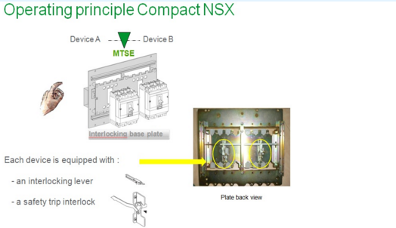
The base of the interlocking is the using of a mechanical device plate which realizes the mechanical interlocking function.
Each circuit breaker is equipped with an interlocking mechanism (interlocking lever) giving the breaker status and a safety trip interlock to disable the closing:
When the breaker N is closed, it’s interlocking lever disable the closing of the breaker R through its safety trip interlock.
When the breaker R is closed, its interlocking mechanism disable the closing of the breaker N through its safety trip interlock.

