Ohmic verification of power contacts
Introduction
Many companies now perform incoming inspections of all purchased equipment including power contactors. Maintenance personnel will also check devices placed in service by measuring device characteristics.
Power contactors and motor starters that are electromechanical in nature will have Normally Open power contacts. To verify the contacts are closing as expected on incoming inspection, the device will either be manually closed or the coil of the device energized. The inspector then measures the contacts with a digital ohmmeter to determine that the contacts are now closed.
Likewise, maintenance personnel remove devices from service to perform similar tests either to attempt determining device serviceability or as part of a troubleshooting process. As with incoming inspection, a digital ohmmeter is used to verify that the contacts have closed after the device is manually or electrically operated.
An examination of the NEMA and IEC standards shows that there are no standards relating to the reliability expected of power contacts at minimum voltage and current levels.
Let’s consider the two cases of incoming inspection and inspection of devices in operation as separate issues.

Incoming Inspection
In the power contactors produced by Schneider Electric, the main metal used in the construction of both power and auxiliary contacts is silver. The exact composition will vary but silver is always the main metal used due to the excellent electrical and thermal conductivity properties. Although the production of devices is performed under stringent conditions to eliminate any contamination of the contacts, once the devices are exposed to outside conditions during transport and storage, the contacts may form a surface layer of silver sulfide also known as tarnish.
Silver is a reactive metal and will form these tarnish layers in the presence of sulfur compounds and moisture. Even though we are not normally aware of them, sulfur compounds are present in the atmosphere. Only moisture needs to be present to start the formation of tarnish. The humidity normally found in the air will provide this moisture. The environment does not have to be in a condensing state for the moisture to be in contact with the surface of the contacts.
This tarnish is a semi-conductor and thus not a good conductor of electricity. Even though the layer of tarnish is very thin, it can present a significant resistance to low voltage and current. However, the tarnish will not present a problem at the voltages and currents associated with power contacts.
Contactors typically have both power and signaling contacts. While there are no lower limits or minimum required voltage and current stated for the power contacts, both NEMA and IEC refer to low level signals relating to auxiliary contacts.
For auxiliary contacts, IEC 60947-5-1 paragraph 4.3.1.1 Note 2 recommends contacting the manufacturer for applications operating below 100v AC or DC. In our catalogs for IEC contactors, the auxiliary contacts are specified as having minimum levels of 17v and 5mA of current to be reliable. Keep in mind that these auxiliary contacts are designed to operate at lower current and voltage levels than the power contacts.
NEMA Standard ICS 5 provides similar information for pilot devices and aux contacts (see Curve 1 ) NEMA ICS2 defines the power contacts and there is no minimum voltage or current stated. They are, by definition, power contacts and therefore concerned with maximum power, not minimum.

Curve 1
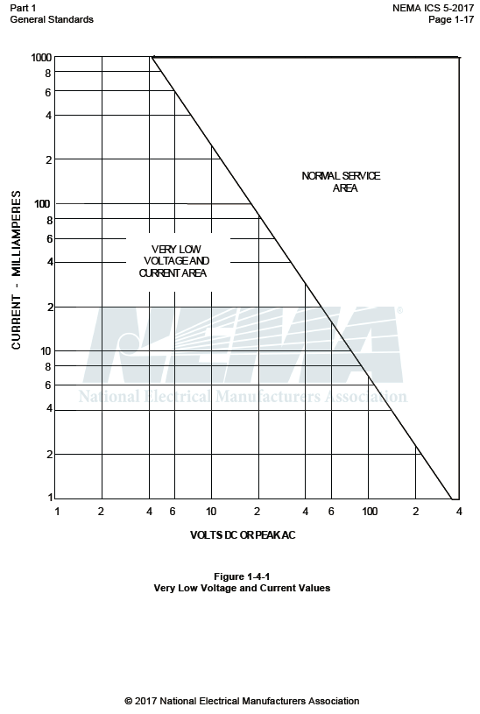

Since we do have minimum references for auxiliary contacts, can operation of these contacts be verified with an ohmmeter? The answer is no. Digital ohmmeters will typically apply a voltage of 3 vdc or less to the circuit being tested. The current flow will be a few milliamps. This means that the voltage and current supplied by the ohmmeter is well below the minimums stated by the standards. This indicates that the results of such testing will be unreliable.
Further, manually operating the contactor will not result in the same contact velocity or contact pressure applied when the device is energized by the coil. The contacts may appear to be in an open state. This can result in devices being rejected that will perform as designed when in actual operation.
This method of incoming inspection or device verification will lead to varying and suspect results. When used to measure resistance, digital meters apply a low voltage to the object under test and measure the resulting current flow. This voltage and resulting current are below the levels acceptable for auxiliary contacts and will be far below the normal operating conditions of the power contacts.

Service inspections
Once placed in service, contacts will begin to wear. An arc will occur both on making and breaking the load (closing and opening the contacts). Even though the arc on closing will be brief in comparison to the arc on opening it is significant on inductive (motor) loads due to the inrush characteristic of the load.
Even when new, the contact surface will present an uneven path to the flow of current. As contacts make and break the current with the resulting arcing, this uneven pattern of resistance will cause the surfaces to wear in a matching pattern. This pattern will produce mating surfaces with a ‘hill’ on one contact matching up with a corresponding ‘valley’ on the other. As the contacts wear, these patterns will move around on the contact surfaces.
As a part of these arcing events and especially on the opening of the contacts, a bridge of molten metal will be created between the separating contacts that will continue to conduct the current. This leads to the current being concentrated in a small area. Once the contacts have achieved sufficient separation, the heating from the concentration of current will cause this bridge to rupture releasing silver particles at a very high temperature. As a result, the arcing will produce various compounds as the silver of the contacts is consumed. This is seen on devices with significant usage as a brown or black deposit. Silver sulfide will be present. If chlorine is present in the atmosphere, there will also be silver chloride which is harder to displace than the silver sulfide.
Understand also that the power contacts will not be pure silver. There are other metals and metallic oxides used to harden the silver in power contacts and make the contacts more resistant to the effects of arcing. These other materials will migrate to the surface of the contacts over time. These metals and oxides will not have the same resistance values as pure silver. They will not present a significant resistance to the flow of electricity at the levels expected for power contacts.
In addition to the deposits and changes of the contacts, there will also be other substances found due to the heat of the arc breaking down the material of the contact chamber. Depending on the arcing current and the design of the contacts, among other things, the temperature of the arc can be 5000 to 20,000 K. For reference, the surface of the sun is approximately 6000K. Fortunately the arcing event is very brief. But with the repetitive nature of contactor operation, the materials of the contact chamber will also break down and contribute to the contamination of the contacts. This is anticipated in the design of the devices.
The result of all these effects, even after a low number of operations, is that the contacts may present a significant resistance in a low voltage/low current test. These changes will not present a barrier to the normal operation of the power contacts as the voltage and current are sufficient to easily overcome these effects. It is only once the contact material is worn away to the backing or support material that there will start to be an effect on the operation.

So how should devices be tested?
For incoming inspection, a test station can be produced that will present a voltage to the contacts that will be low enough to be safe to personnel but still significantly higher than what is produced by an ohmmeter. A variety of loads can be included in the tester such as resistors, industrial relays or incandescent lamps so long as they will allow a significant flow of current. A resistive load of 1 amp at 24 volts AC or DC will be sufficient. As an inductive load is preferred, AC coil versions of the CAD or 8501 X relay will provide an adequate load.
Manual operation of contactors should be avoided. Manually operating a device will not provide the same closing velocity and contact pressure that will be provided by operating the device by energizing the coil. The contactor under test should also be in a normal operating position, upright with the backplate in a vertical plane.
Generally, all equipment must be placed in an electrically safe work condition before an employee works on it; however, in some cases diagnostic testing and troubleshooting is necessary with the device already in service. For example, determining the voltage drop across the contacts while the contactor is energizing the normal load can be more informative than removing the device to a test bench. Energized electrical work, including diagnostic work, must only be done in those situations where it can be demonstrated that:
- It is permissible by national standard, statute or governing regulation. See Table 1.
- Good electrical work practices are applied.
- Appropriate Personal Protective Equipment (PPE) are used.

Table 1: National Standards, Statutes and Governing Regulations for Energized Electrical Work
Geographic Location | Standard, Statute or Governing Regulation
United States | - NFPA 70E, “Standard for Electrical Safety in the Workplace”  - OSHA 1910.333, “Safety-Related Work Practices” standard
Canada | - CSA Z462, “Workplace Electrical Safety Standard”
Mexico | - NOM-029-STPS, NORMA Oficial Mexicana, “Mantenimiento de las instalaciones eléctricas en los centros de trabajo - Condiciones de seguridad”
India | - Indian Electricity Act, 2003  - Indian Electricity Rules, 1956
United Kingdom | - The Electricity at Work Regulations, 1989  - The Health and Safety at Work etc Act, 1974  - HSG85 Safe Working Practices (guidance)
European Union | - ISO 45001, “Occupational Health and Safety Management System” (a Draft International Standard or DIS for public review)  Note: ISO 45001, which will be replacing OHSAS 18001, will be the first internationally agreed Health & Safety management system standard that will be relevant to organizations across the globe.
Norway | - NEK EN 50110-1, “Safety regulations related to the maintenance and operation of electrical installations”

All NEMA Type S contactors have power contacts that can be examined and replaced if necessary. The power contacts of larger IEC LC1D and LC1F contactors can also be examined and replaced.
If the device is a starter equipped with melting alloy or bimetallic overloads, this voltage measurement must be across the terminals of the contactor only. The heating element of the overload will present a significant resistance.
In summary, using the low voltage/low current provided by an ohmmeter for testing of power contacts will lead to erratic results. This is true of both new devices as well as devices that are in service. Use of an ohmmeter can lead to the return of new, unused devices that are fully functional or the early replacement of devices that still have useful life

Bibliography
Electrical Contacts: Principles and Application Edited by Paul G. Slade, Copy right 1999 by Marcel Dekker. A thorough study of all aspects of electrical contacts
NEMA ICS Standards especially ICS 2 and ICS 5
IEC 60947 Standards especially 60947-4-1 and 60947-5-1
“The Performance Implications of Silver as a Contact Finish in Traditionally Gold Finished Contact Applications”, a white paper by Marjorie Myers, Interconnection and Process Technology, Tyco Electronics. Presented at Proceedings of the 55th IEEE HOLM 2009 Conference on Electrical Contacts, September 2009. http://www.te.com/documentation/whitepapers/pdf/Performance_implications_Silver_Myers2009.pdf
“Sulfide Corrosion of Silver Contacts during Satellite Storage” a Technical Report by Reinhold Bauer of Aerospace Corp. El Segundo CA dated Mar 25, 1988 http://www.dtic.mil/dtic/tr/fulltext/u2/a196217.pdf
An Internet search will reveal numerous other sources.

