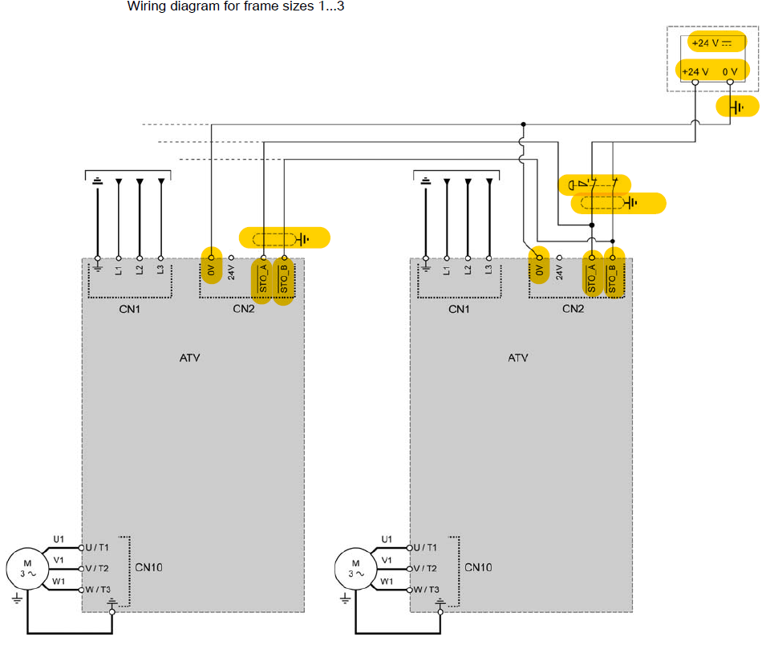
The external supply must follow recommendation below:

The cable must be a shielded cable and connected to the earth like shown on STOA/STOB wiring ( on picture above)

